MINISTRY OF FOREIGN AFFAIRS OF THE REPUBLIC OF UZBEKISTAN
University of World Economy and Diplomacy
Faculty of “International economics and management”
Department of “Systems analysis and mathematical modeling”

Aminjonov Mustafo Anvarjon ugli
Topic: “The impact of Digitalization and the Adoption of High Technologies on Economic Growth in Central Asian Countries (Evidence from Kazakhstan, Uzbekistan, and Kyrgyzstan)”

60412000 - Graduation qualification work for obtaining a bachelor's degree in the direction “International Economics and Management (by region and area of activity)”

The work has been reviewed and recommended for defense:

Scientific supervisor:
Candidate of physical and mathematical sciences, associate professor
Akabirkhodjaeva D.R.
__________________
Head of the department
Doctor of physical and mathematical sciences, professor
Raimova G.M.
__________________
“___ ” ___________ 2026 year.

Tashkent-2026

TABLE OF CONTENTS
INTRODUCTION 3
CHAPTER I. METHODOLOGICAL AND THEORETICAL FOUNDATIONS OF ECONOMIC GROWTH AND DIGITALIZATION 8
1.1. Definitions of ICT, digitalization and high-technology adoption 8
1.2. The role of technology and economic growth theories 15
1.3. Research methodology and analytical ways to estimate the impact of economic growth and digitalization 19
CHAPTER II. INTERNATIONAL EXPERIENCE AND EMPIRICAL ANALYSIS OF DIGITALIZATION AND ECONOMIC GROWTH IN CENTRAL ASIA (KAZAKHSTAN, UZBEKISTAN AND KYRGYZSTAN).. 23
2.1.Assessing Kazakhstan as a benchmark economy in Central Asia: ideas on digital transformation and economic performance…………………………....23
2.2 Comparative benchmarking of digital transformation and hig-technology adoption in Kazakhstan, Uzbekistan and Kyrgyzstan: analytical framework, country selection and cross-country differences…...…………………………..31
2.3. Impact of digitization on economic development of Central Asia: an econometric research (2004-2023 years)..............................................................37
CHAPTER III. INTERGRATING INTERNATIONAL EXPERIENCE AND STRATEGIC SUGGESTIONS FOR UZBEKISTAN ……………………......58
3.1 Present state of digitalization and economic evolution in Uzbekistan………………………………………………………………………..58
3.2. Role of global practices, suggestions and their economic implications for Uzbekistan………………………………………………………………………. 64
CONCLUSION 68
REFERENCES 71

INTRODUCTION
Relevance of graduation qualification work. In recent years, digitalization and the use of cutting-edge technologies have quietly become the main movers of economic development, and also the strategic change across the entire world. Based on information from the World Bank and IMF, the worldwide share of people using the internet rose from 16% in 2005 to 67% in 2022, so basically digital connectivity showed that fast growth.
During the same period, countries with high levels of ICT (Information and communication technology) sensitivity have overall showed powerful productiveness in terms of improvement and also greater integration in global economy. For countries that are located in Central Asia, digital growth has improved differently according to statistics and this is the problem which is relevant.
If we look at the data from World Bank, the internet usage of Kazakhstan stands for 91% in 2022, which is a little higher compared to Uzbekistan with 77% and 58% in Kyrgyzstan. This big difference in digital penetration identifies differences in entrance to digital technologies and recommends potential diverse impacts on economic growth inside the region.
If we look from economic viewpoint, Central Asian economies still have problems with productivity and diversification. World Bank suggests that average GDP per capita rise rates in the region have been unstable over the last 20 years, copying sensitivity to the external shocks and limited technological promotion. In contrast, investment in digital infrastructure has risen at the same time by the growth in mobile subscriptions going to 100 subscribers per 100 people in Kazakhstan by the late 2010s, compared to Uzbekistan and Kyrgyzstan which is lower but have steadily growing levels. These trends point to digital technologies are increasingly fixed in terms of economy, however, their macroeconomic impact stays measured inadequately.
There is clear misunderstanding between the size of digital investments and the limited access of empirical information emphasizing their benefits to economic growth in Central Asia, despite the developed policy on digital transformation. International studies show that there is positive relationship between economic growth and ICT development in advanced and developing economies, while the region stays unchanged in cross-country econometric analyses. Strategic development and digital transformation priorities of Central Asian economies, carrying this research nowadays is particularly vital. An econometric analysis covers the period between 2004 and 2023 based on official statistics, which helps to get result more accurate of the impact of digitalization on economic growth.
Degree of study of the research problem. In modern economic literature, the connection between digitalization, information and communication technology (ICT), and economic growth has been widely studied from both theoretical and empirical angles. You recognize, predating lots of other theories, Paul Romer located growth in the long-run intersections of thought, innovation, and spillover of knowledge. He called this endogenous growth theory. Philippe Aghion and Peter Howitt have also improved theories of growth through the introduction of Schumpeterian models of growth, emphasizing the role of competition in the technologies of progressive waves of destruction and displacement.
Models of creative destruction are applicable in the study of digital technologies, because of the disruption, productivity changes and the creation of new sectors induced by the adoption of information and communication technologies. Hal Varian and Carl Shapiro also brought significant advancements to Information Economics in explaining the new digital economy, how they create new markets and the dynamics of the network effects along with the economics of information. The convergence of all these elements gives you tools for understanding the digital economy, particularly with respect to the effects that digital platforms have upon the economy.
Panel regression models, comparative analysis and fixed effects estimations included in methodological approaches help researchers to control for country-specific characteristics and identify the small effect of digitalization on economic expansion. Building on these well-established scientific methods, this work uses widely known indicators to apply panel econometric methods to annual data for Kazakhstan, Uzbekistan, and Kyrgyzstan from 2004 to 2023.
The object of the graduation qualification work. The research object of this graduation work is the process of economic growth in Central Asian countries, including Kazakhstan, Uzbekistan and Kyrgyzstan within the context of digital transformation and technological development.
The subject of graduation qualification work. The research subject of this work includes the impact of information and communication technology (ICT) and digitalization in particular usage and mobile connectivity on economic growth. Moreover, the economic relationships and mechanisms via which digital technologies affect growth dynamics in the chosen countries.
Aim of graduation qualification work. The aim of this work is to study how digitalization and information and communication technologies effect on economic growth in Central Asian countries at the same time define the major factors impacting growth dynamics and also support scientific recommendations for strengthening Uzbekistan’s digital development strategy using econometric analysis.
Tasks of graduation qualification work. In order to achieve the goal, following steps are set:
- to explore scientific views and theoretical structures related to digitalization, ICT and economic growth;
- to examine the current state and development trends of digitalization in Central Asian countries;
- to do a statistical econometric analysis to assess how digitalization has impacted economic growth between 2004 and 2023;
- to use the economic data to identify important technological problems affecting the growth of the economy;
- to apply international knowledge to develop and evaluate practical suggestions for improving Uzbekistan’s digital development policy;
- to collect and organize statistics on economic development measures and digitalization for Kazakhstan, Uzbekistan and Kyrgyzstan.
Methodology of graduation qualification work. A detailed methodological strategy which combines empirical, statistical and theoretical study methods are used in this work. Economic growth and scientific ideas on ICT and digitalization development are analyzed at the theoretical step through synthesis, generalization analysis. The study’s scientific element relies on studies and comparisons of macroeconomic and digital indicators for Kazakhstan, Uzbekistan, and Kyrgyzstan from 2004 to 2023.
Here is used panel data econometric modeling for statistical and mathematical methods in order to assess how digitalization impacts on economic growth. In order to find important correlations between variables regression analysis is implemented with pooled OLS and fixed effects models. Another thing is, for evaluation empirical findings and develop beneficial recommendations for enhancing Uzbekistan’s digital development plan, methods of modeling are used. All the statistics for the analysis are taken from international databases, such as the World Bank and also reports from the IMF (International monetary fund) and ITU (International telecommunication union).
The structure of graduation qualification work. Graduation qualification work consists of 3 chapters, they are following:
Chapter I focuses to theoretical and methodological foundations of digitalization and economic growth. The key concepts of digitalization, information and communication technologies and economic growth are studied too in this chapter.
Chapter II mainly focuses on international experience and empirical analysis. This chapter shows the reason for choosing Kazakhstan as a benchmark country and gives comparative analysis of digitalization numbers in Central Asia countries. Moreover, chapter II demonstrates econometric analysis based on panel data for Kazakhstan, Uzbekistan and Kyrgyzstan over the 2004-2023.
Chapter III is focused on adaptation of international experience and strategic advises for Uzbekistan. The current condition of digitalization in Uzbekistan is also examined in this chapter with international experience. Also, practical recommendations are given to improve the role of digitalization in helping economic growth.
CHAPTER I. METHODOLOGICAL AND THEORETICAL FOUNDATIONS OF ECONOMIC GROWTH AND DIGITALIZATION
  - Definitions of ICT, digitalization and high-technology adoption
The integration of digital technologies into the socio-economic structures of many countries has been accelerated by globalization and the rapid advancement of technology. The proliferation of the Internet and digital communications, in conjunction with mobile technologies, has distorted the functioning of economies and resulted in new patterns of growth and new development initiatives.
This is particularly the case for Central Asia and Europe, even though these regions have particularly heterogeneous economic structures, and even though the penetration of digital technologies is uneven. The policymakers are able to recognize the real changes only if they are able to theorize the relationship between digital technologies and economic growth. Although there is a great deal of literature dealing with the impact of digitalization on the economy at the global level, there is a lack of focused studies that address specific regions with certain and heterogeneous economic conditions.
The case of Central Asia and Europe is particularly interesting in that the economic development, digital infrastructures, and policy frameworks in these regions are heterogeneous. Information and Communication Technologies or ICT, are frequently cited as one of the most disruptive technologies in the current phase of economic development.
Academic discourse on ICT refers to a suite of technologies that are interrelated to the electronic capture, storage, processing, transmission, and delivery of information. These technologies encompass networks and infrastructures of telecommunications, the Internet, computing, and digital communication. According to the World Bank, ICT plays a fundamental role in reducing transaction costs, increasing productivity, and improving market access in both developed and developing economies.
Information and Communication Technologies (ICT) represent a broad set of technologies used for the collection, storage, processing and transmission of information through electronic systems. In economic literature, ICT is commonly understood as a combination of telecommunications infrastructure, computing systems, software and digital networks that enable economic coordination and value creation.
The Information and Communication Technology (ICT) sector is kind of the backbone for digital transformation, you know. Also, even though the digitalization of the economy spreads into all sectors, to different extents, it seems most obvious in the Content and Media sector. These two highly digital areas together make up the Information Industries, which is a key aggregate, and it has been widely used to judge digital performance across countries. The growing significance of these industries underscores the need for well-designed definitions to enable cross-country comparable measurement, which in turn supports evidence-based digital policymaking.
The history of ICT
The economic importance of ICT started to get serious academic interest toward the end of the twentieth century, especially after the productivity paradox discussion that Robert Solow helped kick off. In his classic work on technological change and economic growth, Solow (1957) argued that long term output growth is not something you can pin entirely on capital and labor getting accumulated; rather, technological progress is a key lever, if not the main one. From a more theoretical angle ICT is often studied as part of technological progress and productivity expansion, sort of in the same orbit.
Solow himself kept stressing that technology matters for long run growth, he also implied that when output rises, it can’t be fully, or even mostly, accounted for by capital and labor alone. Later empirical research extended this idea by identifying ICT as a key driver of Total Factor Productivity (TFP). By the early 2000s, empirical studies began sort of measuring ICT capital in a more systematic way, and then checking how it feeds into Total Factor Productivity (TFP). Jorgenson and Stiroh (2000) showed that investment in ICT capital, really had a noticeable role in productivity growth in the United States, across the 1990s. Their research provided quantitative evidence that ICT investments were not merely complementary assets but core drivers of economic expansion.
Figure 1.1.1. Individuals using the internet (%)
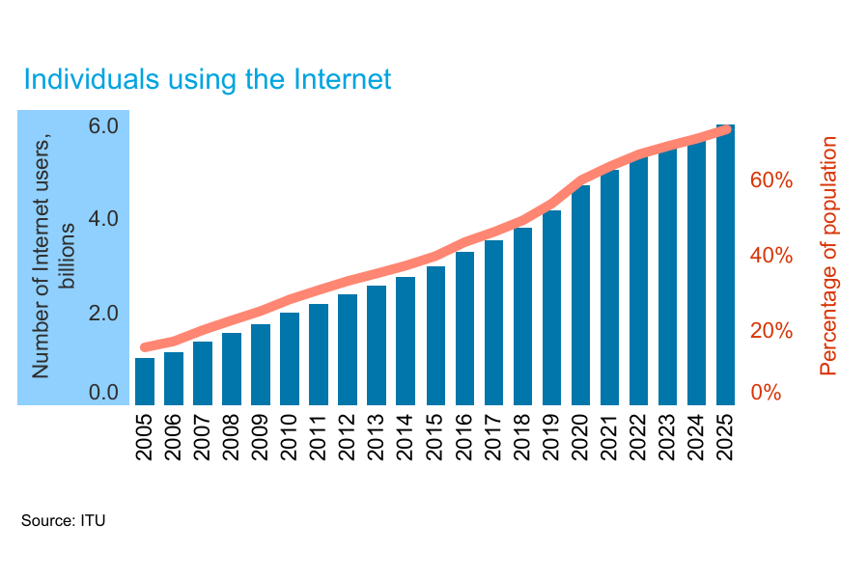
Source: https://www.itu.int/en/ITU-D/Statistics/Pages/stat/default.aspx
ITU thinks roughly 6 billion folks, or about 74 per cent of the world’s population, will be using the Internet in 2025. It is a jump from around 60 per cent back in 2020, and it is estimated that 1.3 billion people have come online in that same stretch. Still, even with that progress, about 2.2 billion people remain offline.
While ICT tends to point toward technological tools and infrastructure, digitalization is more like a bigger systemic shift, kind of, a transformation in the whole environment. In practice, digitalization means bringing digital technologies into economic, organizational, and social routines-yes those routines. This doesn’t only update methods, it tends to reshape how value gets produced and then how it is delivered, overall.
It is also worth keeping the difference between digitization and digitalization clear, because people mix them up easily. Digitization is essentially the act of turning analog information into a digital format, step by step. Digitalization, on the other hand, implies deeper structural change-more like a transformation of business models, production systems, governance mechanisms, as well as the way labor is organized.
Digitalization
The idea behind digitalization, it is kind of more than just digitization. Because digitization is basically about turning information into a digital format, while digitalization is more like weaving digital tools into economic and organizational routines, you know the way things get done. Erik Brynjolfsson and Andrew McAfee also point out that digitalization shifts, business models, labor markets and the usual productivity patterns. They say this happens because automation becomes easier, data analytics gets more momentum, and network-based coordination starts working in the background, connecting things across organizations. Their work highlights how digital technologies reshape entire industries rather than merely improving existing processes.
The economics of digitalization cannot be fully understood without examining network effects and platform markets. Varian and Shapiro (1999), in Information Rules, demonstrate how digital goods exhibit increasing returns to scale and strong network externalities. Digital platforms partially create value by connecting users, reducing search costs and facilitating transactions. Network effects imply that the value of an online service increases with actual adoption. This characteristic somewhat accelerates digital adoption, and also causes market concentration.
Brynjolfsson and McAfee (2014) from The Second Machine Age essentially says that digital technologies have reached a level where the fundamentally change productivity patterns, by enabling automation and decision making based on data.
According to their analysis, digital transformation differs from previous technological revolutions because of its exponential development speed and scalability.
The OECD defines the digital economy as an economy that is significantly enhanced by digital technologies, data flows, and digital platforms. In general, the digital economy tends to be marked by quite a few things, like:
- a heavy dependence on data as an input resource
- platform-based market arrangements
- strong network effects alongside scalability
- fast spread of innovation
When we zoom in on Central Asia, digitalization shows up alongside rising internet penetration, stronger mobile connectivity, and deeper integration with global digital markets. So, digitalization is not only a technical path, but also an institutional one, and it needs supportive infrastructure, adequate human capital and regulatory frameworks that actually work, otherwise it just stalls.

Figure 1.1.2. Individuals using the internet (% of population)

Source: Prepared by the author based on https://databank.worldbank.org/reports.aspx?source=2&type=metadata&series=IT.NET.USER.ZS
Understanding of high-technology
High technology (high-tech) is generally defined based on technological intensity and R&D investment. The OECD classification system categorizes industries according to R&D expenditure relative to value added, distinguishing high-technology, medium-high, medium-low, and low-technology sectors.
Typically, high technology includes:
- High-level telecommunications
- Electronics manufacturing and computers
- Biotechnology
- Aerospace
- Artificial intelligence & advanced software
Endogenous technological change was introduced by Romer (1990), meaning that knowledge accumulates, and innovation is capable of providing an advantage that leads to sustainable growth. According to the endogenous growth theory, technology is not external to the process but is rather internal due to the conscious decisions made. In other words, technology is generated by human capital and research and development activities. The degree of high technology can be measured through the degree of dependence on highly developed technologies. According to the Organization for Economic Co-operation and Development (OECD), sectors are considered high-technology sectors depending on their R&D intensity and knowledge wealth. High adoption of technology in growth theory means that advanced technology is diffused throughout the industry in a proper manner, like broadband, artificial intelligence, cloud computing, and digital platforms. Paul Romer argues in endogenous growth theory that technological diffusion and knowledge spillovers generate increasing returns and sustained economic growth.
Figure 1.1.3. Conceptual framework linking digitalization and economic growth.

Source: Prepared by the author based on Solow (1957) and Romer (1990)
Economic growth and digitalization have a connection illustrated in Figure 1.3.1 below. Digitalization plays an essential role in technological progress since it entails construction of ICT infrastructure, providing individuals with access to internet as well as facilitating improved mobile connectivity. According to both the neoclassical and endogenous theories, technological progress contributes to growth in productivity by reducing transaction costs, enhancing efficiency and diffusion of knowledge (Solow, 1957; Romer, 1990). Therefore, digital infrastructure facilitates innovation and productivity through enhanced accessibility of information and diffusion of new technologies, as well as allowing companies to participate in global value chains.
The Schumpeterian theory of economic growth corroborates the above idea. According to Aghion & Howitt (1992), innovation fosters structural change through adoption of better technologies and techniques as opposed to the old ones. Consequently, digitalization acts as a channel for fostering new technology adoption to promote economic growth. Moreover, digitization increases trade integration and accumulation of capital by removing market barriers and increasing connectivity, thus boosting investment and global competitiveness. Finally, all of these factors lead to higher GDP per capita growth, which is used as primary indicator of economic performance.
1.2. The role of technology and economic growth theories
The connection between technology and economic growth has been an important topic within economic theory throughout the years. Technology is believed to be one of the most important reasons for increasing productivity, structural changes, and economic growth both in traditional theoretical approaches and the new growth paradigm. In the context of digitalization and advanced technology adoption, it is necessary to analyze the role of technological progress in the framework of growth theories.
Neoclassical Growth Theory and Exogenous Technological Progress
The neoclassical growth theory was basically formulated by Robert Solow in 1956 and 1957. Solow modified growth theory with the incorporation of a production function involving capital, labor, and technology. In his framework, technological progress is treated as an exogenous factor that shifts the production function upward over time. According to Solow (1957), increases in capital accumulation alone cannot explain long-term economic growth. Instead, the residual component-commonly referred to as “total factor productivity” (TFP)-captures the contribution of technological progress.
Studies that apply the Solow growth model empirically indicate that technological innovation rather than increased labor and capital contribute significantly to growth in developed economies. In cases of digitalization, factors such as ICT networks, internet connectivity, and cellular connectivity constitute aspects of technological innovation that enhance productivity. Digital technologies decrease transaction costs, coordinate production, and facilitate the flow of information, thereby increasing output. Thus, from a neoclassical perspective, digitalization acts as an exogenous productivity-enhancing factor influencing GDP growth. However, a major limitation of the Solow model is that it does not explain how technological progress is generated. Technology is assumed to grow independently of economic decisions. This limitation led to the development of endogenous growth models.
Endogenous Growth Theory and Innovation Dynamics
Endogenous growth theory emerged in the late 1980s and early 1990s to address the shortcomings of exogenous models. Paul Romer (1990) introduced a framework in which technological change results from intentional investment in research and development (R&D) and human capital accumulation. In Romer’s model, knowledge spillovers generate increasing returns to scale, allowing economies to sustain long-term growth.
Unlike the Solow model, where technology is external, endogenous models treat innovation as an internal outcome of economic incentives. Firms invest in R&D because knowledge creation leads to new products and productivity gains. In digital economies, investments in ICT infrastructure and digital platforms stimulate innovation ecosystems and generate spillover effects across industries.
Aghion and Howitt (1992) further developed the Schumpeterian growth model, emphasizing “creative destruction” as the core mechanism of technological progress. This perspective argues that growth stems from constant innovation and creativity, through which newer technologies replace older ones. Digitalization is one of such innovations, since traditional means of production become automated and data-oriented. The existing evidence proves that internally generated growth is an important aspect in digital economies. Studies show that ICT adoption increases firm productivity, enhances innovation capacity, and fosters knowledge diffusion. For less developed nations, digital infrastructure reduces entry barriers and makes them participants of international markets. Therefore, using endogenous growth theory as an approach to investigating the impact of digitalization factors on GDP per capita growth for the countries of Central Asia would be appropriate.
ICT as a General-Purpose Technology
Another important theoretical perspective is the concept of General-Purpose Technologies (GPTs). Bresnahan and Trajtenberg (1995) define GPTs as technologies that have broad applicability across sectors and generate complementary innovations. The previous examples include electricity and steam engines. In the present context, ICT can be considered a multifunctional technology which benefits several industries simultaneously by enhancing communication, automation, and the use of digital platforms. According to the OECD (2023), digital technologies enhance productivity by enabling firms to optimize supply chains, adopt cloud computing solutions, and leverage big data analytics.
In emerging economies such as Kazakhstan, Uzbekistan, and Kyrgyzstan, digitalization may accelerate convergence with advanced economies by reducing information asymmetries and lowering transaction costs. This aligns with empirical findings suggesting that ICT infrastructure positively correlates with economic growth, particularly when complemented by institutional quality and human capital development.
Digitalization, Productivity, and Structural Transformation
Beyond aggregate growth models, digitalization influences microeconomic efficiency and sectoral dynamics. Digital technologies reduce coordination costs, increase market transparency, and foster competition says World Bank (2016). These mechanisms enhance allocative efficiency and resource utilization. Brynjolfsson and McAfee (2014) argue that digital technologies represent a “second machine age,” characterized by automation, artificial intelligence, and data-driven decision-making. These innovations increase output levels and can even transform occupations. Hence, digital transformation is an enabler that enables the transition of the economy from lower value-added activities into more valuable ones, thus leading to structural change.
Taking a macroeconomic perspective, the digitization process increases TFP (Total Factor Productivity) levels, which is the key determinant of sustainable economic growth. Empirical analyses conducted by the IMF (2018) demonstrate that countries with higher ICT penetration tend to experience stronger productivity growth, particularly when supported by favorable regulatory environments. Thus, digitization influences growth through various channels by increasing productivity, innovation, trade, and capital.
Numerous empirical studies confirm the positive relationship between digitalization and economic growth. For instance, Czernich et al. (2011) found that broadband infrastructure significantly increases GDP growth rates in OECD countries. Similarly, Qiang, Rossotto, and Kimura (2009) demonstrated that a 10 percent increase in broadband penetration can raise GDP growth by up to 1.38 percentage points in developing economies. In emerging markets, the growth effect of digitalization depends on complementary factors such as institutional quality, education, and trade openness. This is particularly relevant for Central Asia, where structural reforms and digital policies are evolving.
1.3. Research Methodology and Analytical Approaches to Estimating the Impact of Digitalization on Economic Growth
The research explores the connection between digitalization and economic growth applying a methodological approach that is based on economic theories and data analysis. As it works with macro-level statistics for Kazakhstan, Uzbekistan, and Kyrgyzstan from 2004 to 2023, a combination of descriptive, comparative and panel econometric methodologies will be used.
Research Design and Data Structure
This research applies a quantitative approach utilizing macroeconomic secondary data sources. Specifically, it focuses on three countries of Central Asia-Kazakhstan, Uzbekistan, and Kyrgyzstan within the timeline of twenty years (2004-2023). The selection of this time frame allows for capturing structural digital transformation processes and ensuring sufficient observations for panel econometric estimation. The empirical approach follows the tradition of growth regressions widely applied in macroeconomic research. Panel data methodology is particularly appropriate for this study because it combines cross-country and time-series dimensions, increasing estimation efficiency and controlling for unobserved heterogeneity.
Panel data models are commonly used in empirical growth literature when analyzing the impact of technological and institutional variables on economic performance. A panel regression analysis will be applied as it enhances cross-sectional or time-series analysis by addressing country-specific characteristics that do not change over time yet have an impact on economic growth.
Data Sources and Independent Variables
The research relies on reliable international data to make sure the results can be validated and compared.
Sources of data:
- World Bank: World Development Indicators (WDI)
- ITU
- IMF
- Worldwide Governance Indicators (WGI)
The dependent variable in this study is:
- GDP per capita growth (percent per year)
This indicator reflects improvements in economic performance adjusted for population changes and is widely used in empirical growth literature.
The key explanatory variables representing digitalization include:
- Internet users (% of population)
- Mobile cellular subscriptions (per 100 people)
These indicators are standard proxies for ICT penetration and digital adoption
Control variables are included to account for additional determinants of economic growth:
- Trade openness (% of GDP)
- Inflation (consumer prices, annual %)
The inclusion of control variables follows established growth regression practices to reduce omitted variable bias.
Econometric Model Specification
Empirical analysis is done using an improved growth regression model using the Cobb-Douglas production function as the basis for the analysis. In line with the Solow growth model and its empirical extensions.
Panel Data Estimation Techniques
Three main estimation approaches are considered:
1. Pooled Ordinary Least Squares (OLS)
The pooled OLS model treats all observations as homogeneous and ignores country-specific heterogeneity. At the same time this method may lead to biased estimates if unobserved country characteristics influence growth.
2. Fixed Effects Model (FE)
The fixed effects estimator controls for time-invariant country-specific factors, such as institutional structure or geographic characteristics. Given the structural differences between Kazakhstan, Uzbekistan, and Kyrgyzstan, the fixed effects model is particularly suitable for this analysis.
3. Random Effects Model (RE)
The random effects model assumes that country-specific effects are uncorrelated with explanatory variables. The Hausman test is used to determine whether fixed or random effects provide consistent estimates.
In macroeconomic panel studies, fixed effects models are often preferred when analyzing a limited number of countries over time, as they provide more robust control for heterogeneity.
Analytical Justification for the Methodological Approach
The use of panel regression in this study is theoretically justified by endogenous growth theory, which suggests that technological adoption influences long-term productivity and growth. Empirical literature demonstrates that ICT penetration significantly contributes to GDP growth, particularly when combined with investment and trade integration. Czernich et al. (2011) find that broadband expansion positively affects economic growth in OECD countries. Similarly, Qiang et al. (2009) show that ICT infrastructure has stronger growth effects in developing economies when institutional conditions are supportive. Therefore, applying panel econometric techniques to Central Asian countries allows testing whether similar mechanisms operate in transition and emerging economies.

CHAPTER II. INTERNATIONAL EXPERIENCE AND EMPIRICAL ANALYSIS OF DIGITALIZATION AND ECONOMIC GROWTH
2.1. Kazakhstan as a benchmark economy in Central Asia: digital transformation trajectory, economic outcomes, and policy lessons
Kazakhstan is treated as the benchmark
Kazakhstan is treated as the benchmark country among Kazakhstan, Uzbekistan, and Kyrgyzstan not because it is free from digital problems, but because it represents the most institutionally mature and strategically consistent case of digital transformation among the three. OECD’s 2023 assessment describes Kazakhstan as a country that has been building an ambitious digitalization agenda since 2013 and states that the country has already developed a comprehensive digital government system while beginning to establish the legal and regulatory conditions for the digital transition of the wider economy.
This is a stronger foundation than in the other two selected countries, where digital reforms are important but institutionally less consolidated. In addition, Kazakhstan remains the largest and highest-income economy among the three: according to World Bank country data for 2024, its GDP reached USD 291.48 billion and GDP per capita USD 14,154.6, compared with USD 114.97 billion and USD 3,161.7 in Uzbekistan, and USD 17.48 billion and USD 2,420.2 in the Kyrgyz Republic. From a methodological point of view, this makes Kazakhstan the most suitable reference case for evaluating how digitalization and high-technology adoption may interact with economic growth in Central Asia.
The idea of using Kazakhstan as a benchmark is also supported by the regional and academic literature. Marco Bianchini and Insung Kwon, in the OECD regional study Private Sector Digitalization in Central Asia, treat Kazakhstan as the most advanced private-sector digitalization case in the region, while also showing that its transformation is still incomplete. When conducting research on public governance, Baurzhan Bokayev et al. analyze e-government reform initiatives in Kazakhstan through a citizen perspective. They argue that Kazakhstan has transcended its digitalization of government administration and gone into more service-related reforms. Further, Gul Jussupova et al., including Bokayev and Dauletbay Zhussip, analyze digital government initiatives in Kazakhstan. In other words, Kazakhstan has already generated enough institutional experience and scholarly attention to function as a benchmark, while Uzbekistan and Kyrgyzstan remain more clearly in the phase of catch-up and selective adaptation.
In addition, it is important to select Kazakhstan because of its likeness to the other two states and high level of development, which would allow effective benchmarking. Specifically, all three states represent former Soviet republics, landlocked nations, and transitional economies. Moreover, they all use state-driven approaches to modernization. However, Kazakhstan managed to accumulate more experience in terms of creating digital systems, financial and administrative capabilities needed for reforms, and positions within international rankings. This balance between comparability and differentiation is essential in a graduation thesis. If Kazakhstan were too different, it would not be a useful benchmark. If it were too similar, it would not show a meaningful gradient of digital maturity. Instead, Kazakhstan occupies the precise middle ground needed for benchmarking: close enough to be relevant, yet sufficiently ahead to illuminate the path of regional digital development.
Evolution of Kazakhstan’s digital strategy
Kazakhstan’s digital strategy did not begin with a single isolated program. OECD notes that the country’s digital transformation of the economy “started a few years ago” and that in 2013 Kazakhstan was already among the first countries in the region to adopt a digital program as part of economic policy. This matters because benchmark status is not created by a single project; it is created by policy continuity. During the first stage of digital development, Kazakhstan emphasized the importance of combining digitalization efforts and provision of public services along with general economic modernization.
Therefore, Kazakhstan was able to outperform two other countries due to its earlier approach to digitalization. The second major phase was the Digital Kazakhstan Strategy, which OECD describes as having been launched in 2018 and as successful in developing a comprehensive digital government system and starting to establish the legal and regulatory conditions for the digital transition of the Kazakh economy.
According to the regional paper by OECD, the Digital Kazakhstan initiative (2018-2022) had digitalization of the economy as one of its objectives, with special emphasis put on such sectors of the economy as mining, oil and gas industry, and manufacturing, where technologies for increasing production efficiency became a priority. Moreover, Kazakhstan's digital strategy envisaged several programs and tools for developing the digital ecosystem. According to OECD, among those was the creation of the Astana Hub International Technology Park announced in 2018. Also, the Cybershield Kazakhstan cybersecurity program that was developed by Kazakhstan attracted special attention of the OECD authors.
As noted in the same regional paper, Kazakhstan started implementing its third five-year digital strategy called DigitEL in early 2022. This strategy is focused on providing an enabling, secure environment online, using ICT companies as a driver for growth, as well as digitalizing services. All this is important since it demonstrates that the leadership of Kazakhstan maintains its activity in digital area, consistently improving its strategy, rather than simply relying on achievements of the past. Kazakhstan’s case is stronger precisely because its digital policy has been updated rather than abandoned.
The latest development within this trend is embodied in the Digital Acceleration for an Inclusive Economy (DARE) Project, financed by the World Bank and approved in February 2024. According to the World Bank, the DARE project aims at providing “high-quality, resilient broadband” in unconnected communities with a view to reaching over a million residents of remote villages.
It is also worth mentioning that according to the World Bank press release, the DARE Project is connected to Kazakhstan's development goals outlined in the National Development Strategy 2025 as well as in the Digital Kazakhstan State Program in terms of innovative and digital transformation as means to achieve sustainable and competitive economic development. That change makes Kazakhstan very useful as a benchmark for countries like Uzbekistan and Kyrgyzstan, where inclusion, access, and productivity remain important digital-development problems.
What international indicators show
Kazakhstan took 24th place in the Un E-Government Development Index (EGDI) 2024 with the 0.9009 at the same time as Uzbekistan was ranked 63rd with 0.7999, and Kyrgyzstan 78th with 0.7316. By these numbers we can understand that Kazakhstan stays in a higher place in terms of e-government, also it has more satisfying numbers and more is more improved in digital public-service delivery, telecommunication infrastructure, and human-capital. Since public digitalization is one of the most visible outputs of state-led digital reform in Central Asia, the EGDI provides one of the strongest international justifications for choosing Kazakhstan as the benchmark country.
Next important standard is the Global Innovation Index (GII) 2024. WIPO gives following numbers: Kazakhstan took 78th place, standing 5 places higher of Uzbekistan at 83rd and more than 20 places than Kyrgyzstan at 99th. Kazakhstan demonstrates the headline rank and also the structure of Kazakhstan’s innovation performance, for that reason Kazakhstan’s profile plays significant role. WIPO finds that Kazakhstan’s main strengths as government’s online service (rank 8), utility models by origin per billion PPP GDP (rank 10), and e-participation (rank 15).
In general Kazakhstan is pretty good when it comes to ICTs and they got a solid position in high-exports also. However, it has some areas that they should work on them, for example R&D and software spending. They have also succeeded digital government capacity and administrative digitization which is why they are putting a standard from which others can take a lesson. That is exactly why it is a benchmark within Central Asia, not a fully advanced digital economy by global standards.
World Bank indicators reinforce this picture. On the World Bank’s country data pages, internet use in Kazakhstan reached 93.39% of the population in 2024, compared with 90% in Uzbekistan and 92% in the Kyrgyz Republic. In terms of secure digital infrastructure, the contrast is even sharper: World Bank data show 6,914 secure internet servers per one million people in Kazakhstan in 2024, compared with 967 in Uzbekistan and 1,302 in the Kyrgyz Republic.
It is awesome that these numbers show that Kazakhstan has a strong digital infrastructure. They may have more internet users, but it is not a real reason for this, their setup can find solutions for serious online stuff. When we think about transactions and tech-intensive business activities, it is obvious that Kazakhstan just nails it. In other words, Kazakhstan’s lead is more visible in the quality and architecture of digitalization than in basic access alone.
Effect of digitalization on economic dynamics
We can have clear understanding about the economic significance of digitalization of Kazakhstan, when we look through the economy of it. OECD says that mineral resources and oil are helping to stay strong in the ranking with around 70% of total foreign direct investment between 2016 and 2020. Furthermore, report shares with the information that the energy sector and share of fossil fuels had about 72% of goods exports since 2013, at the same time energy sector showed 17% of GDP in 2019. These numbers play a high-role for digitalization of Kazakhstan, with the help of which we can easily understand why it matters so much. Kazakhstan is not just improving for comfort, it is trying to use digitalization for a long-term strategy which decreases excessive dependence on growth. In this case, it becomes a tool for transformation of structure of the economy.
OECD fully agrees with this view. It says that making it easier for the private sector to go digital can help Kazakhstan achieve its long-term goals of diversifying its economy and promoting growth. The report also mentions that during the year of the COVID-19 pandemic many Kazakh businesses moved their operations online which helped reduce the negative impact on the economy. Digitalization helps businesses cope with times by letting them keep working talking to customers and serving them even when things get tough.
The broader World Bank framework in Digital Dividends explains that digital technologies can generate faster growth, more jobs, and better services, but only when they are supported by “analog complements” such as competition-friendly regulation, skills, and accountable institutions. Another way digitalization helps is by making the government work efficiently. Kazakhstan’s high ranking and WIPO strengths, in online government services and e-participation show that digitalization has greatly improved the government’s ability to provide services cut down on paperwork and make it easier for people and businesses to interact with the government. This is also pointed out in studies. Bokayev and co-authors argue that Kazakhstan’s e-government trajectory should be judged not merely by the presence of online portals, but by how digital tools improve citizen interaction and service delivery. Jussupova, Bokayev, and Zhussip similarly discuss digital government maturity as the stage at which technology begins to transform the logic of public administration rather than only digitize existing paperwork. In economic terms, such improvements reduce transaction costs, shorten administrative delays, and improve the business environment, all of which can raise productivity indirectly.
A third channel is innovation and technology adoption in firms and sectors. OECD’s Central Asia review notes that Kazakhstan’s digitalization agenda has included the use of 3D printing and the Industrial Internet of Things in industry. This can make a problem as it combines digitalization to actual production processes. Recent empirical studies on Central Asia also support the economic relevance of these channels. Shodiev, Turayey, and Shodiyev find a positive ICT-growth relationship in Central Asian countries.
Kuldasheva, Eshov, and Ismailova show that digital-economy variables, including ICT and e-commerce, are significant in explaining economic growth in the five Central Asian republics. Yuldoshboy and co-authors conclude that ICT can be a sustained driver of economic growth in Central Asia, but only with complementary factors such as human capital and institutional strength. Taken together, these studies do not prove that Kazakhstan’s digitalization automatically causes every macroeconomic gain, but they do strongly support the argument that digitalization is a meaningful part of the region’s growth model.
What lessons matter for Uzbekistan and Kyrgyzstan
The first lesson for Uzbekistan and Kyrgyzstan is that digitalization works best when it is integrated into a long-term economic-development strategy, not treated as an isolated ICT program. Kazakhstan’s experience shows the value of durability: a digital schedule that took place in 2013, a structured national program in 2018, follow-up ecosystem tools such as Astana Hub and cybersecurity initiatives, and continued investment through DigitEL and the DARE project. Uzbekistan is already moving in this direction. The World Bank’s documentation on the Digital Uzbekistan 2030 strategy states that the Uzbek government plans to increase the size of the digital economy by at least 2.5 times, expand software outsourcing tenfold to USD 500 million, and bring digitalization of government workflow to 90%. The lesson from Kazakhstan is that such ambitions need stable implementation architecture and not only headline targets.
The second lesson is that public digital services are necessary but not sufficient. Uzbekistan’s OECD review stresses that the private sector has not yet fully harnessed the opportunities created by the government’s digital strategy because firms still lack the institutional framework, awareness, and digital skills needed for effective uptake. Kazakhstan’s experience shows us that with good e-government and high international rankings many companies in the private sector are not using digital technology very much.
Kyrgyzstan is another example that makes this point very clear. The World Bank said in its 2025 Country Economic Memorandum that Kyrgyzstan is not growing well because its workforce is not very skilled and the investments it gets are not very good. For Kyrgyzstan what Kazakhstan is doing tells us that digital plans need to be connected to how productive companies how skilled the workforce is and how good the investments are. If not, digitalization will not have an impact and will be all over the place.
The third thing we learn is that the quality of the infrastructure is more important than having access to it. Kazakhstan’s example shows that just because many people are using the internet it does not mean that companies will start using technology if the internet is not very fast if it does not reach rural areas and if it is not safe. This is very important for Uzbekistan and Kyrgyzstan where digital technology is not being used equally in all areas and by all companies.
For Uzbekistan the lesson is to focus on using technology in a way that helps companies be more productive. For Kyrgyzstan the lesson is more basic: digital transformation needs to be built on a connection that always works the ability to put plans into action and an environment that helps companies. In both countries Kazakhstan’s experience tells us that connecting areas to the internet helping small and medium-sized companies use digital technology and teaching people digital skills are just as important, as having good e-government rankings.
The final lesson is methodological as well as policy-related: benchmarking should guide adaptation, not imitation. Kazakhstan’s digital trajectory cannot simply be copied because Kazakhstan’s scale, fiscal resources, administrative capacity, and international investment profile differ from those of Uzbekistan and especially Kyrgyzstan. But Kazakhstan does offer a useful regional demonstration of what matters most: policy continuity, integration of digitalization with diversification goals, attention to digital government and business ecosystems simultaneously, and the use of international indicators to monitor progress. For that reason, Kazakhstan remains the most appropriate benchmark in this thesis, while Uzbekistan and Kyrgyzstan remain indispensable comparative cases that reveal where digital transformation still needs deeper institutional and productive foundations.
2.2. Comparative benchmarking of digital transformation and high-technology adoption in Kazakhstan, Uzbekistan and Kyrgyzstan: analytical framework, country selection and cross-country differences
Digitalization as a driver of economic growth
Digitalization has become one of the most important structural determinants of modern economic growth, because it affects not only access to information and communication technologies, but also innovation capability, firm productivity, public administration efficiency, and the diffusion of advanced technologies across sectors. For this reason, the present section does not reduce digital transformation to a single ICT variable. In this section, digitalization is treated as a broader process, not just as internet access. It includes the development of digital infrastructure, online public services, the use of digital tools by businesses, innovation capacity, and some indicators related to high-technology activity.
Such an approach is consistent with the OECD measurement framework, which stresses that digital transformation must be assessed through indicators ranging from education and innovation to trade, economic outcomes, and public policy performance. From a methodological perspective, this approach is especially important for Central Asia, where digital transformation is uneven and where the economic effects of digitalization depend not only on internet access, but also on state capacity, quality of institutions, business readiness, and the ability to translate digital access into productive and innovative activity.
The UN ESCAP background paper on North and Central Asia emphasizes that digital transformation in the subregion cannot be understood only through connectivity indicators, because sectoral applications in e-commerce, finance, agriculture, supply chains, and logistics are equally important for sustainable development. In the same way, OECD work on Central Asia argues that digital transformation should be studied both through infrastructure and through the extent to which firms, especially SMEs, actually adopt digital tools and integrate them into business activity.
International academic literature also supports a broader interpretation of the digitalization-growth nexus. In the European Union, Magoutas, Chaideftou, Skandali, and Chountalas show that ICT development is positively associated with GDP performance and that the contribution of digital transformation is strengthened when it is combined with e-government progress and human-capital enhancement. In another recent comparative study, Correa and Esquivias conclude that digitalization, education, and institutional quality positively influence economic growth in both Sub-Saharan Africa and the Middle East, while the strength of the effect depends on differences in institutional development and learning capacity. These studies are important for the present thesis because they demonstrate that the economic impact of digitalization is rarely direct or automatic; rather, it is mediated by complementary factors such as education, governance, innovation, and policy design.
Many researchers have already studied this issue in Central Asia but there is not much research as in Europe or East Asia. Shodiev, Turayey, and Shodiyev examined the ICT-growth nexus for Central Asian countries over 2000-2018 and found that ICT variables such as fixed broadband subscriptions and internet use positively affected GDP per capita. Kuldasheva, Eshov, and Ismailova studied five Central Asian republics over 2000-2022 and concluded that e-commerce and ICT had a significant positive relationship with economic growth in the region.
More recently, Yuldoshboy and co-authors investigated whether ICT functions as a sustained driver of growth in four Central Asian economies over 2000-2022 within an extended endogenous growth framework, while Kurmanov and colleagues reported a significant positive impact of ICT on economic growth, especially in Kazakhstan and Uzbekistan. These studies show that the connection between technology and economic growth in Central Asia is an area that has been studied before but it needs more research that compares different countries and finds examples to learn from. Given this it makes sense to compare Kazakhstan, Uzbekistan and Kyrgyzstan.
First these countries are all in the region and have some things in common: they used to be part of the Soviet Union they are landlocked and the government plays a big role in modernizing the economy and reforming the public sector. Second all three governments have plans to transform their countries digitally which makes them similar in terms of policy. Third even though they have some things in common these countries are very different when it comes to how they use digital technology how innovative they are, how well they can implement new technologies and how much businesses use digital tools. This mix of similarities and differences makes them a good choice, for comparison. In words they are similar enough to be compared but different enough to show how digital technology, new technologies and economic growth are related in different ways.
Within this group, Kazakhstan can be treated as the benchmark economy. OECD notes that Kazakhstan has been developing an ambitious digitalization agenda since 2013, while its dedicated Digital Kazakhstan program operated as a five-year plan from 2018 to 2022. As per the OECD’s regional review and its coverage on Kazakhstan, broadband and other Internet-related services, and e-services were complemented by high-speed connectivity, upskilling the workforce, and special one-stop business services, cyber security, and digital finance, e-payments, and e-commerce, making Kazakhstan’s digital policy the broadest and most integrated among the other two countries.
With this digital policy intervention, the OECD cites the coverage of the program, the application of 3D printing and Industrial Internet of Things (IoT) in the extractive and manufacturing industries, which is pertinent to the ‘high technologies’ of this current thesis. Hence, internet connectivity is not what sets Kazakhstan apart, but the association of digital means with industrial and public sector modernization that is unprecedented in the region. I
In this regard, Kyrgyzstan is an equally important case, but for other reasons. As per the OECD’s review, the Digital Kyrgyzstan 2019-2023 program seeks to lay the basic foundations of digital transformation with regional backbone networks, broadband fiber optics, and promotion of digital literacy. The same source notes that the government launched the Tunduk unified identification and authentication system and accelerated online public services during the COVID-19 period.
Kyrgyzstan has a lower rank than Kazakhstan and Uzbekistan when Digital Development is assessed. In the Global Innovation Index 2024, Kyrgyzstan ranks 99th, and its neighbors rank ahead of it. Nonetheless, Kyrgyzstan has shown progress in Digital Access. In 2024, it is projected that 92% of the population will have internet access, and in 2023, there were 109 mobile subscriptions for every 100 people. In contrast, fixed broadband is lacking.
In 2024, there were 6.4 subscriptions to fixed broadband for every 100 people in the Kyrgyz Republic, which is lower than both Uzbekistan and Kazakhstan. This mixed picture indicates that Kyrgyzstan has achieved significant basic digital access, but has not yet converted that access into a comparable level of institutional digital maturity, innovation depth, or technology-intensive economic performance.
Digital Development in Uzbekistan is ahead of Kyrgyzstan, but still lags most of Kazakhstan. In the last several years, significant efforts to bolster Digital Development have taken place in Uzbekistan. The OECD has indicated that the years following 2016 were a period of substantial reform in Uzbekistan. The Digital Uzbekistan 2030 Strategy was launched in 2020, and will seek to embed digital technologies in public services, infrastructure, the economy, and education in Uzbekistan. A particularly important result of the comparative assessment is that public-sector digitalization is generally stronger than firm-level digitalization across Central Asia. OECD’s regional note points out that, based on World Bank Enterprise Survey rounds between 2017 and 2021, the percentage of Central Asian firms having their own website was below peer-group averages.
The gap between upper-middle-income comparators and Kazakh firms was 14% points, while the gap between lower-middle-income comparators and Uzbek firms was 19.2% points. OECD also notes that Kazakhstan’s internal gap between large firms and small firms in website use was 40.8% points, which suggests that even in the regional leader, digitalization remains uneven across the business sector. This observation is highly relevant for the present thesis, because it implies that growth effects from digitalization in Central Asia may depend not only on internet access or e-government development, but also on whether digital tools diffuse beyond the public sphere into firms, SMEs, manufacturing, trade, and service activities.
Accordingly, it is insufficient to simply posit that Kazakhstan's level of digitalization surpasses that of both Uzbekistan and Kyrgyzstan. A more sophisticated level of analysis sees that all three countries are at varying levels and possess different characteristics of digital transformation. Specifically, Kazakhstan's digital government, strategic, and innovative infrastructures as well as its secure-server and high-tech export infrastructures, are more advanced than all the other countries, thus providing justification for its position as a benchmark case.
Given this, the most illustrative reference case for this thesis is undoubtedly Kazakhstan, as comparative benchmarking of the three countries clearly supports this argument. Also, the case placement being presented here is not mechanical copying. Kazakhstan is a more informative case because it offers an example of how improved digital strategies and institutional structures are related to improved e-government, innovation, and technology indicators. Uzbekistan and Kyrgyzstan are included in this analysis because of the varying distances, different levels of implementation, and different reform strategies that they possess in relation to the benchmark. This comparative framework will be used in the following sections of this chapter in two ways. The first will be a more focused discussion on Kazakhstan as the benchmark, and the second will be an econometric analysis to examine the impact of the digital and high-tech industries on the economic growth of the three countries.
2.3. Econometric analysis of the effect of digitalization on economic development of Kazakhstan, Uzbekistan, and Kyrgyzstan (2004-2023 years)
Objectives and tasks of the study
Our main aim here is to figure out how digitalization has affected economic growth in Kazakhstan, Uzbekistan, and Kyrgyzstan between 2004 and 2023. To do this, we've chosen GDP growth as our go-to dependent variable. The big factors we're focusing on are how people use the internet, the rise of mobile phone plans, and improvements in broadband connections.
For the analysis, we take a look at pooled OLS, fixed effects, and random effects models. After that, we use the Hausman test to see which model works best. Overall, this study is really diving into how these IT factors impact the per capita GDP, a key metric for measuring economic development. When it comes to the actual numbers, our econometric study includes yearly panel data for those same countries and years. This info is mostly from the World Bank’s World Development Indicators (WDI). Also, the ITU database is where a lot of the digitalization metrics come from in the WDI.
Dependent variable:
- gdpcap: GDP growth (annual %)
Independent variable:
- inuser: individuals using the internet (% of population)
- broad: fixed broadband subscriptions (per 100 people)
- mobsub: mobile cellular subscriptions (per 100 people)
- trade: trade (%of GDP)
- inflat: inflation, GDP deflator (annual %)
These indicators were picked because they are relevant and we have information about them. We made sure they are all on the scale.
Figure 2.3.1. Types of variables
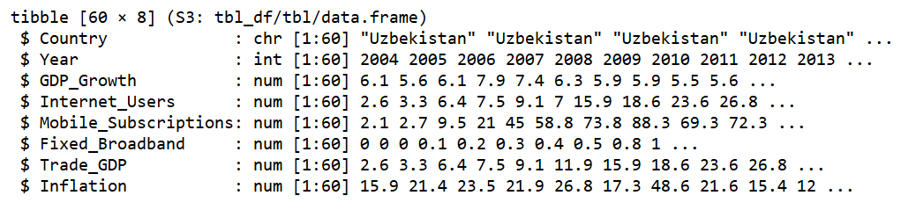
Source: Prepared by the author
The data shown is a set of numbers for 3 countries over 20 years (2004-2023). There are 60 entries, one for each country per year. The entries include economic numbers.
The main variable is GDP per capita, which indicates the average per capita income. Other variables include:
- gdpcap: GDP growth (annual %)
- inuser: individuals using the internet (% of population)
- broad: fixed broadband subscriptions (per 100 people)
- mobsub: mobile cellular subscriptions (per 100 people)
- trade: trade (%of GDP)
- inflat: inflation, GDP deflator (annual %)
Figure 2.3.2. Information about variables
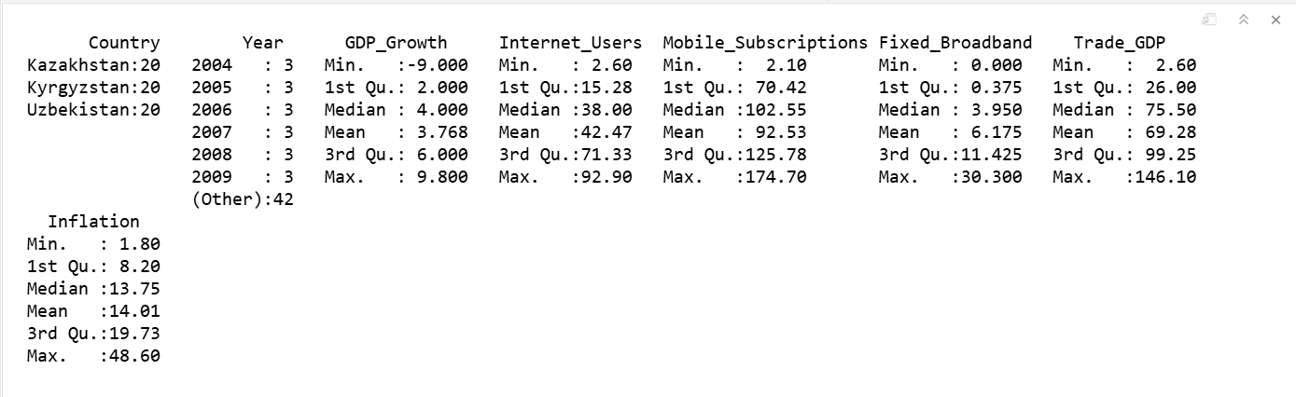
Source: Prepared by the author
This summary in Figure 2.3.2 shows what the data looks like. The data is for 3 countries, each for 20 years from 2004 to 2023. The average GDP growth rate for all three countries is 3.6%. The growth rate varies from -9% (Kyrgyzstan, 2020) to +9.8% (Kazakhstan, 2006). The numbers show some variation because of economic conditions and events like the 2008-2009 financial crisis and the 2020 COVID-19 pandemic. More people got the internet across the countries with an average of around 46%.
The number of people with the internet varies a lot (2.6%-92.9%) because these economies became more digital from 2004-2023. On average there are 91 mobile subscriptions per 100 people with Kazakhstan having the most. The average number of fixed broadband subscriptions is 7.2 per 100 people. This means that fixed broadband is not as developed as phones. Kyrgyzstan has a trade-to-GDP ratio (, up to 146%). Uzbekistan has had a trade openness historically. Inflation varies a lot (1.8%-48.6%) with Uzbekistan having high inflation in the early years.

Figure 2.3.3. Boxplot analysis by country
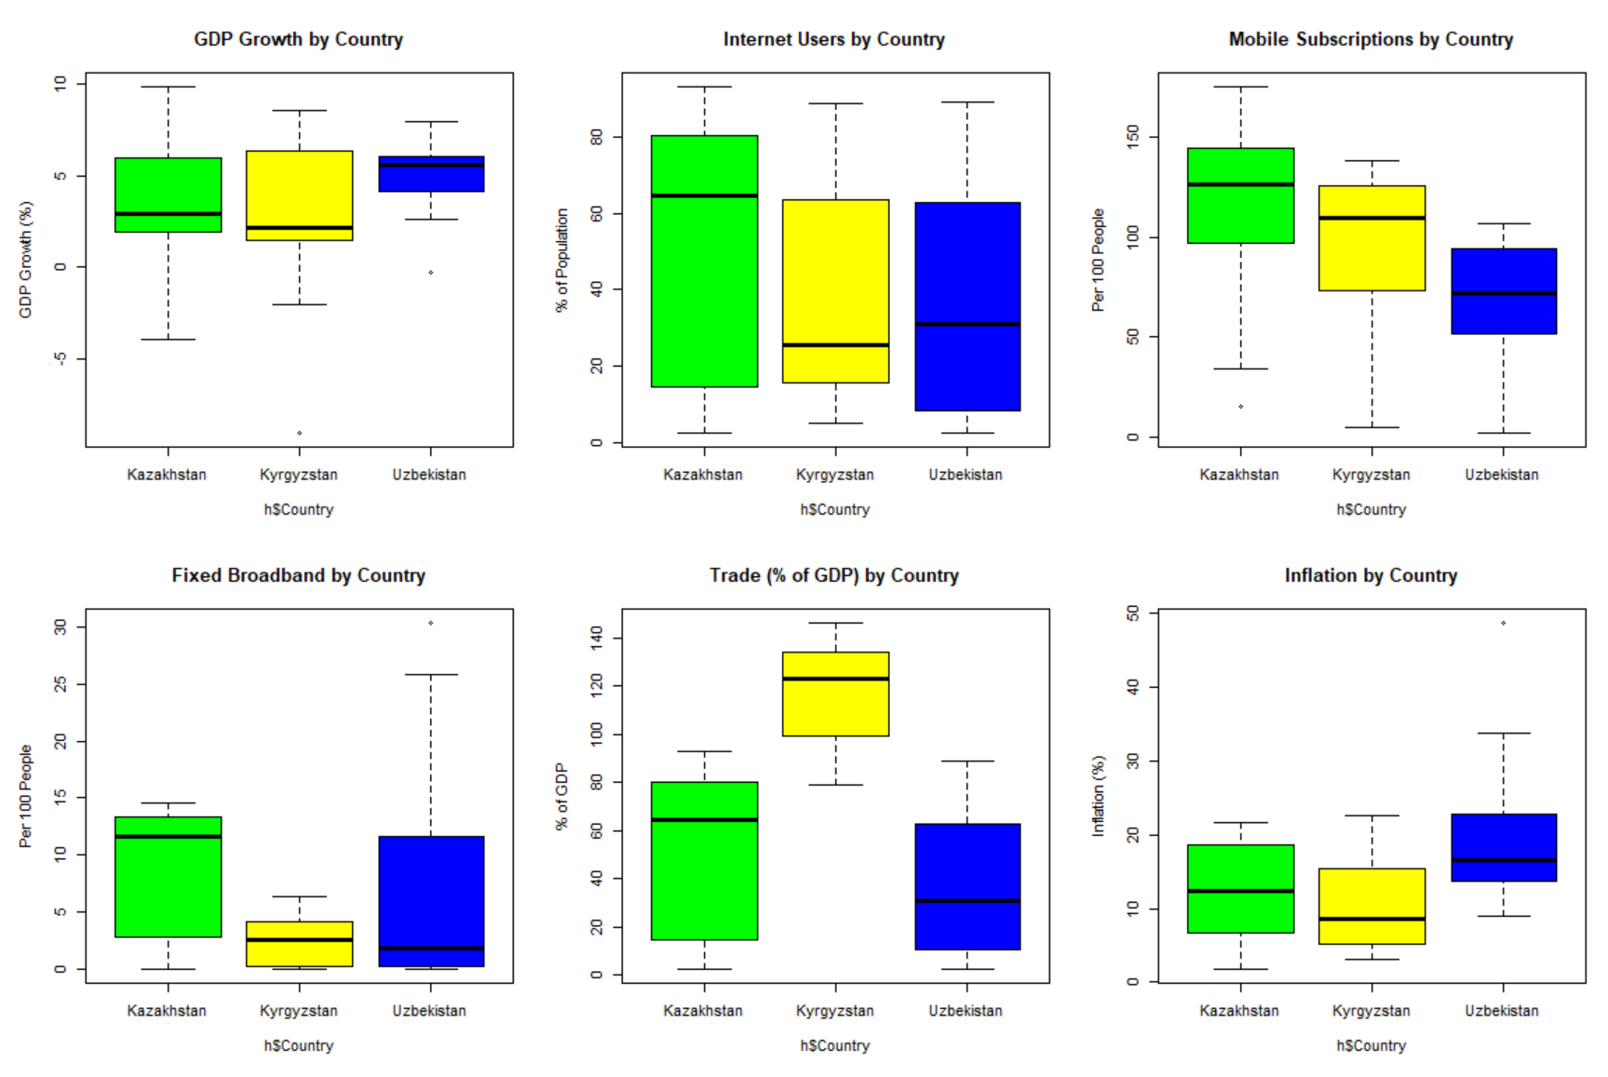
Source: Prepared by the author
Figure 2.3.3 shows us how the main variables are spread out in Kazakhstan, Kyrgyzstan, Uzbekistan. We can see the values and how much they vary. We can also see if there are any points that do not fit in. Kyrgyzstan has the spread and the most unusual points. This means that Kyrgyzstan has a lot of ups and downs in the economy. Kazakhstan is more stable. Has better growth at the top end. Uzbekistan is growing steadily. Not as fast, as Kazakhstan. When it comes to internet use Kazakhstan is the leader. Uzbekistan is second.
Kyrgyzstan has lower internet use with a lot of variation. All three countries have a lot of people using phones. Kazakhstan has the mobile phone users. There are some points that are very high which is typical of people who use multiple phone cards. All three countries have low fixed broadband values, but Kazakhstan is again the leader. Uzbekistan has shown recent growth. Kyrgyzstan's trade-to-GDP ratio is substantially higher and more volatile-reflecting its reliance on re-export trade and smaller domestic market. Uzbekistan shows significantly higher and more variable inflation, particularly in the early years. Kazakhstan and Kyrgyzstan are more moderate.
Figure 2.3.4. Boxplot analysis by year
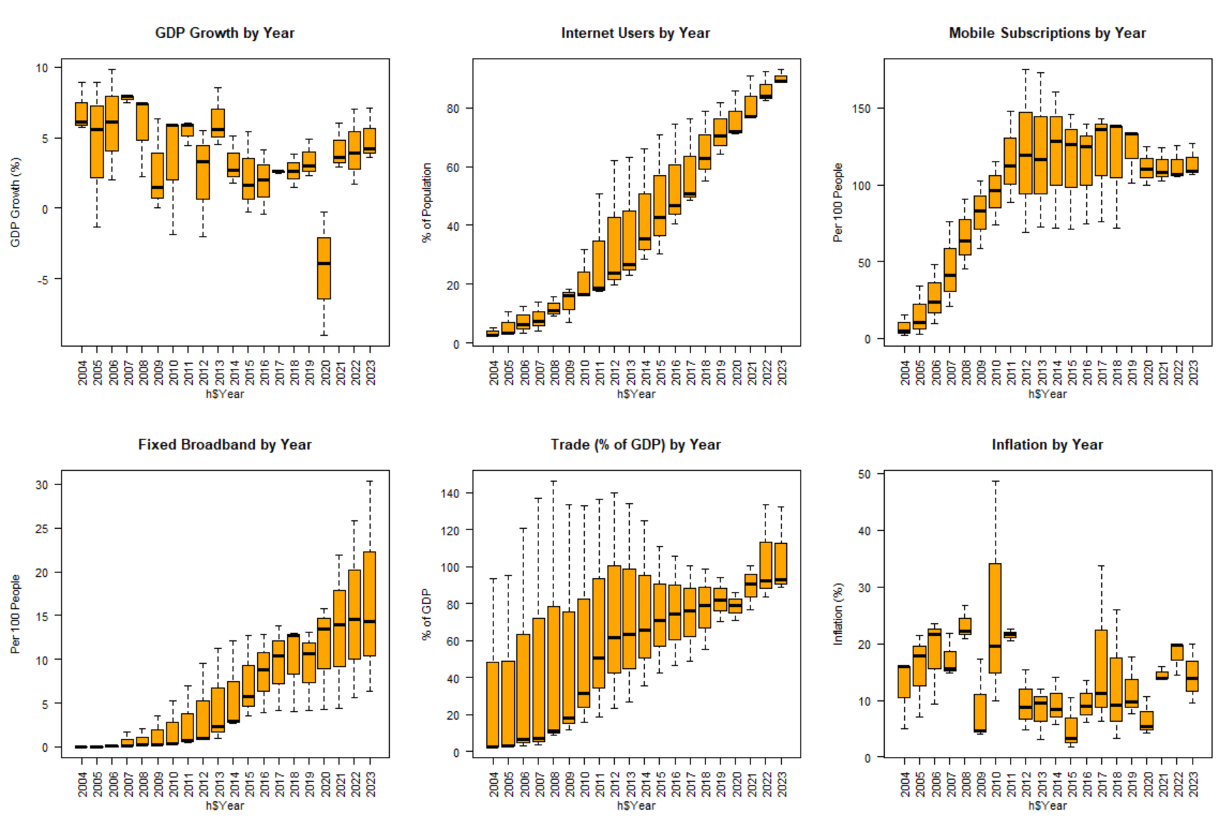
Source: Prepared by the author
Figure 2.3.4 shows a boxplot analysis by year. The GDP growth shows negative shocks in 2009 the global financial crisis and in 2020 the COVID-19 pandemic. These shocks are visible as drops across all countries. The number of Internet users shows an upward trend every year. This confirms that there is digitalization across the region from 2004 to 2023. The Mobile subscriptions grew rapidly through 2011 and 2012. Then they stabilized as market saturation was reached. The Fixed broadband shows consistent growth. The growth especially accelerated after 2015. The Trade shows a declining trend after 2010. This decline is particularly notable for Kyrgyzstan. There was also a disruption in 2020. The Inflation was notably high and variable in the years from 2004 to 2008. It stabilized in the period. Then it spiked again in 2022 due to commodity shocks.

Figure 2.3.5. GDP growth
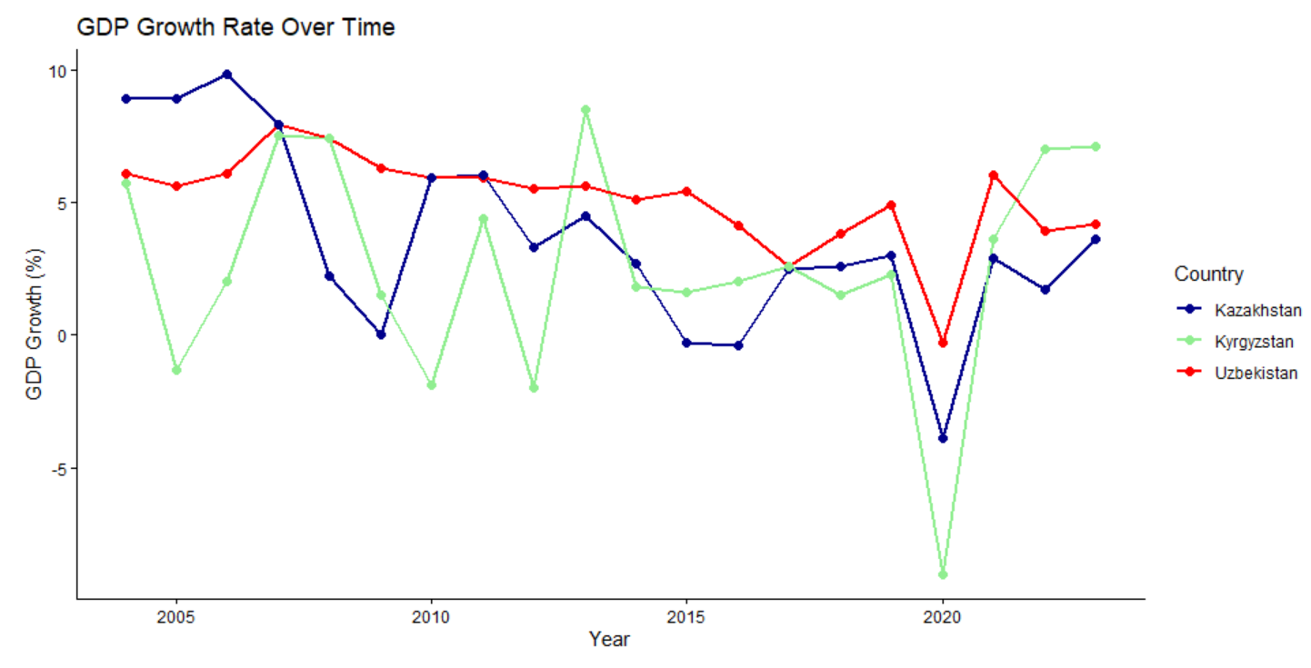
Source: Prepared by the author
All three economies experienced growth in 2020. This was due, to the COVID-19 pandemic. Kazakhstan was severely affected, with a growth rate of -3.9%. Kyrgyzstan showed the volatility across the period. It had a contraction in 2020, of -9%. Uzbekistan maintained resilient growth throughout.
Figure 2.3.6. Internet users (% of population)
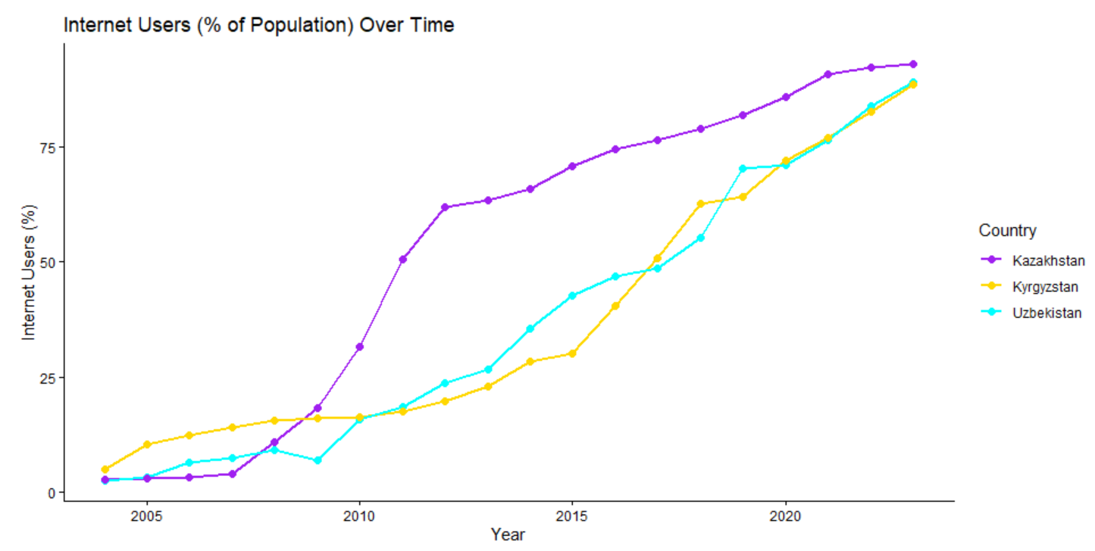
Source: Prepared by the author
All three countries show a clear upward trend. Kazakhstan was consistently ahead. By 2023, all three exceed 88% penetration, indicating near-universal access.
Figure 2.3.7. Mobile subscriptions (Per 100 people)
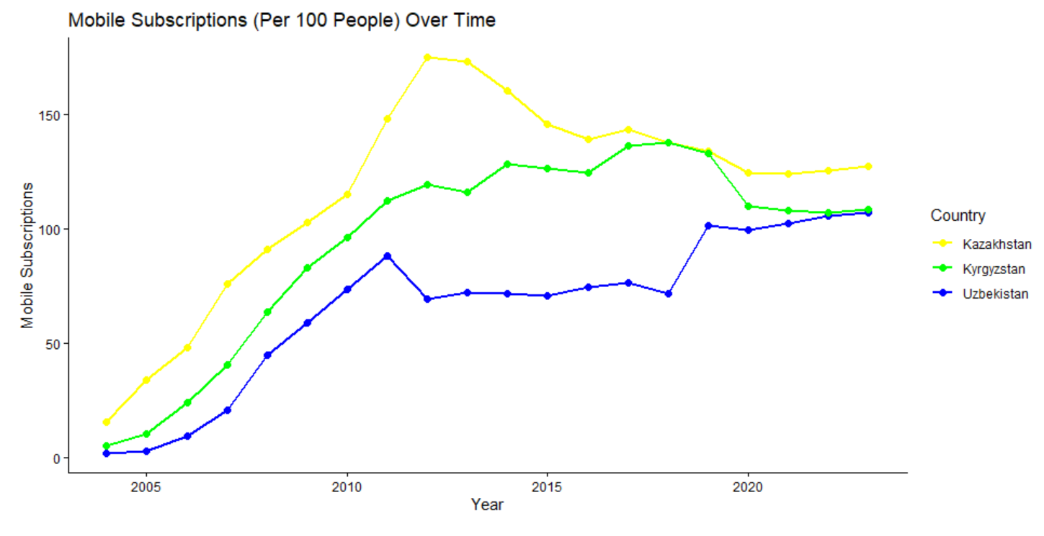
Source: Prepared by the author
From Figure 2.3.7, there is an obvious trend of increasing mobile subscriptions in Kazakhstan, Kyrgyzstan, and Uzbekistan. Throughout most of the study period, Kazakhstan subscriptions were the highest. Up until the early 2010s, subscriptions grew rapidly. After that time, the subscriptions started to stabilize and decline. In contrast, Kyrgyzstan subscriptions continued to grow rapidly until the late 2010s, when the rate started to decline. Uzbekistan subscriptions were the lowest in the study period, but rapidly grew after the 2018-2019 period. The graph illustrates that all three countries mobile communication subscriptions were rapidly growing, but the rates of growth varied among the countries and the time periods.

Figure 2.3.8. Inflation rank
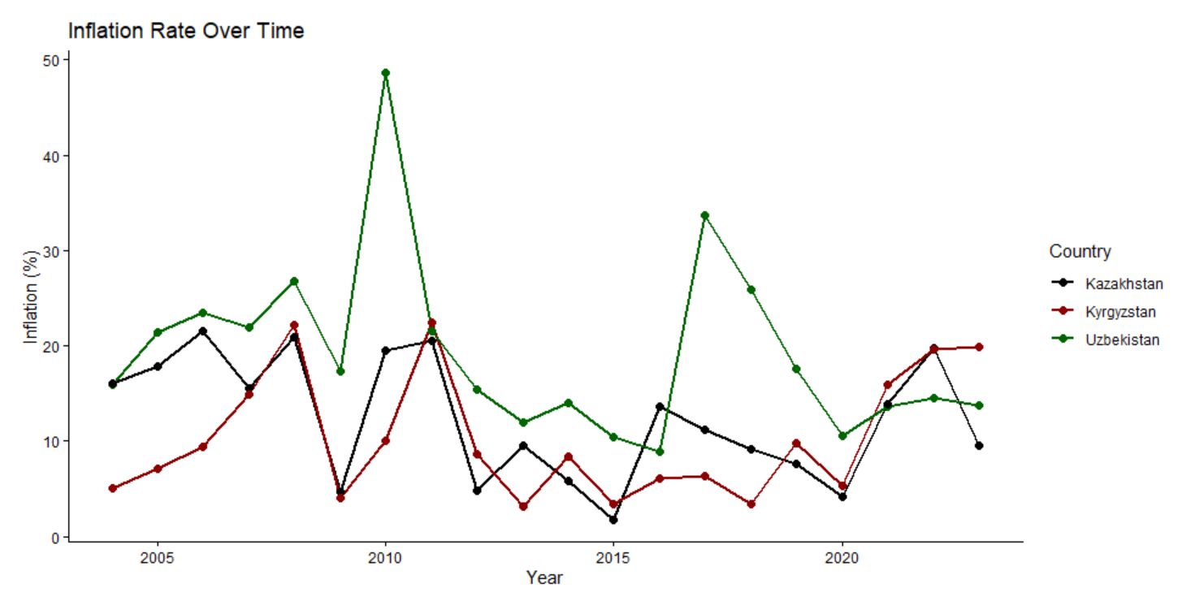
Source: Prepared by the author
Figure 2.3.9. Fixed broadband subscriptions

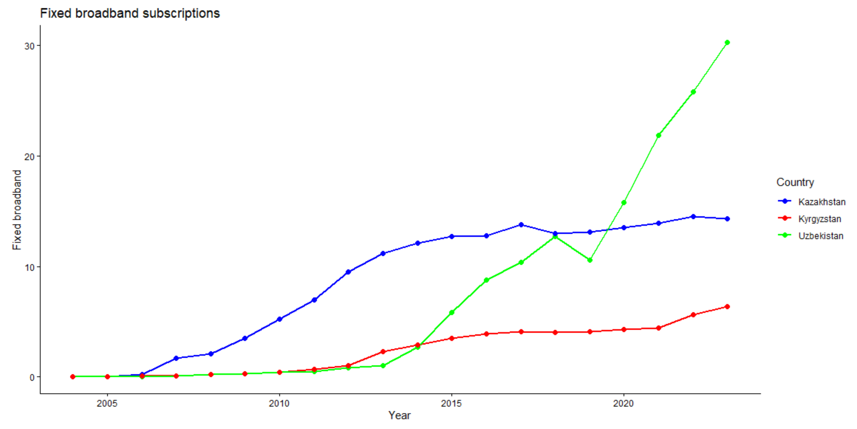
Source: Prepared by the author
Figure 2.3.9 depicts subscription trends to fixed broadband across three countries. All three countries show upward trends, with subscription growth in Kazakhstan showing the least variability and then being the leading country overall. There were flat trends in broadband subscription growth in Kyrgyzstan, which sustained the lowest subscription levels among the three countries. Rapid subscription growth was evident in Uzbekistan starting from the low levels in the mid-2010s, finally overtaking the subscription growth in the other two countries. This shows that broadband subscription infrastructure was the first to develop in Kazakhstan, the slowest in Kyrgyzstan, and the most rapidly in Uzbekistan.

Figure 2.3.10. Trade (% of GDP)
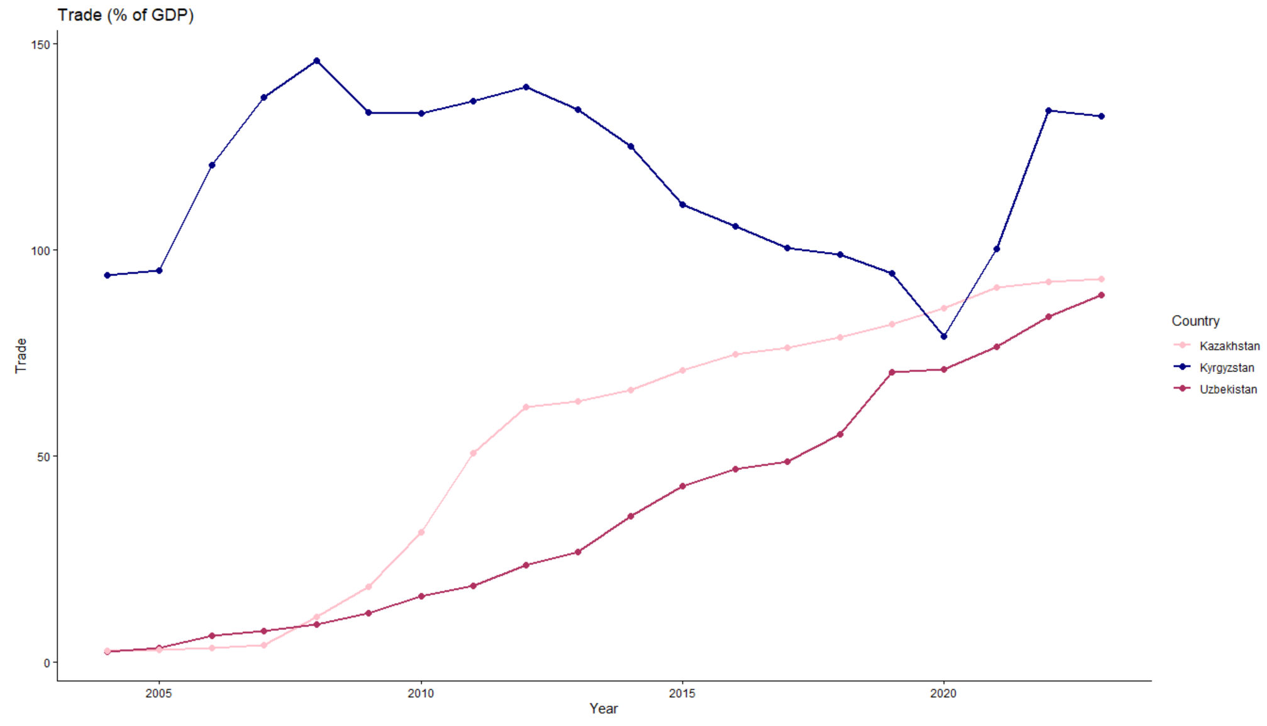
Source: Prepared by the author
Trade-to-GDP ratios are displayed in Figure 2.3.10. Kyrgyzstan was the leader among the three countries, but the indicator was highly unstable. The low ratios of trade to GDP in the other two countries were also on the rise. The early and later stable trade growth in Kazakhstan was contrasted by the steadily increasing trade growth in Uzbekistan. Overall, greater and more sustainable trade integration was observed in all three countries with Kyrgyzstan being the most open.
Scatter plot analysis of the relationship between GDP growth and explanatory variables
Figure 2.3.11. Internet users vs. GDP growth

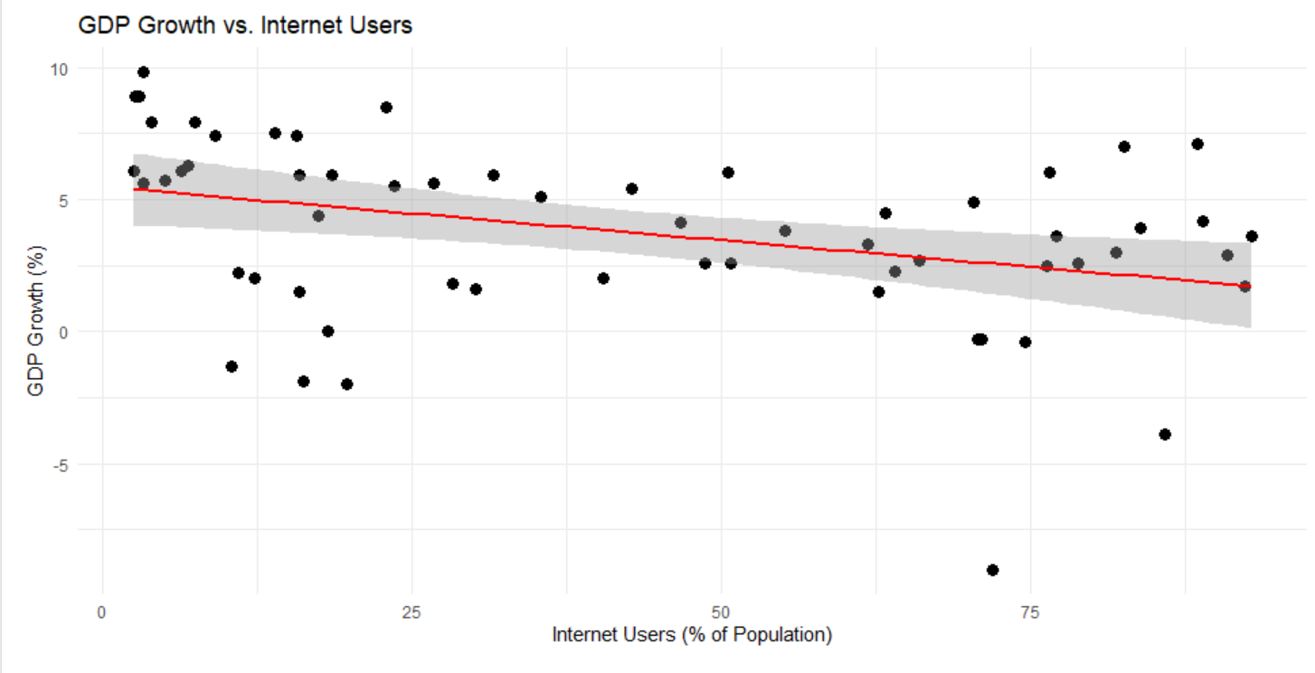
Source: Prepared by the author
Figure 2.3.11 shows a weak negative relationship between internet use and GDP growth. Although the fitted line slopes downward, the observations are widely scattered, suggesting that the bivariate relationship is not strong. This means that internet use alone cannot explain changes in GDP growth and that further econometric analysis is necessary.

Figure 2.3.12. Fixed broadband subscription vs. GDP growth
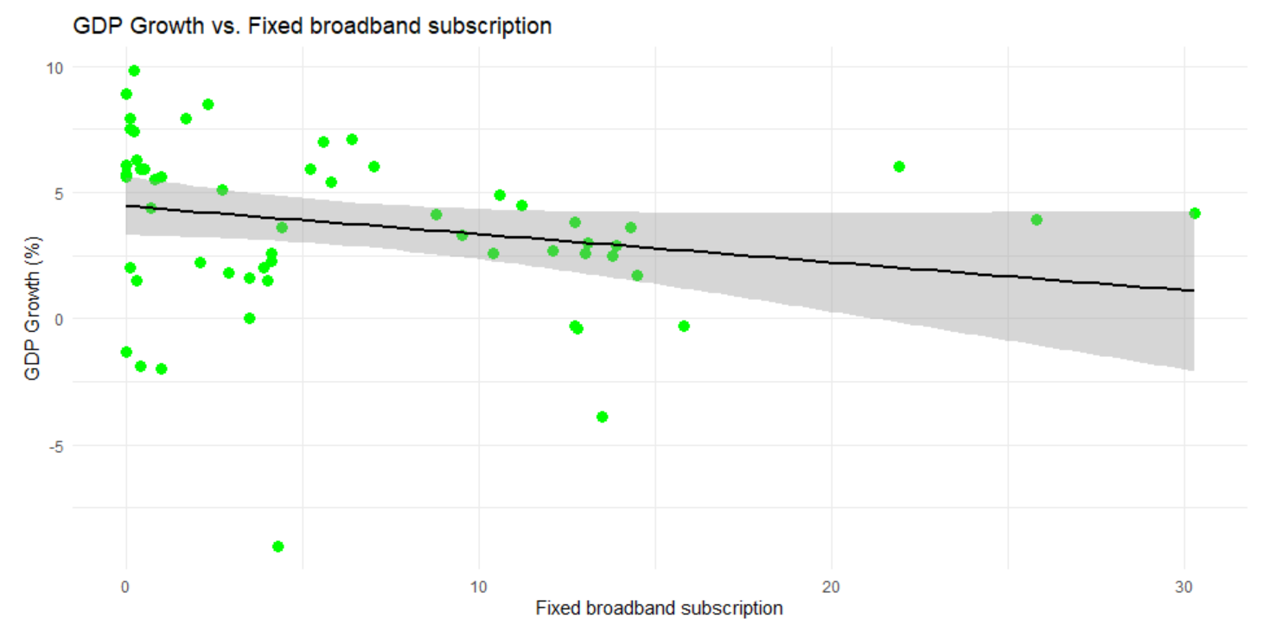
Source: Prepared by the author
Figure 2.3.12 shows that there is a weak negative correlation between the rate of growth in GDP and fixed Broadband Subscription growth. Because there is a weak correlation between the two indicators, the trend line fitted to the most widely dispersed data should be treated as only a very preliminary assessment. Panel regression should serve as the primary method for deriving conclusions.

Figure 2.3.13. Correlation matrix
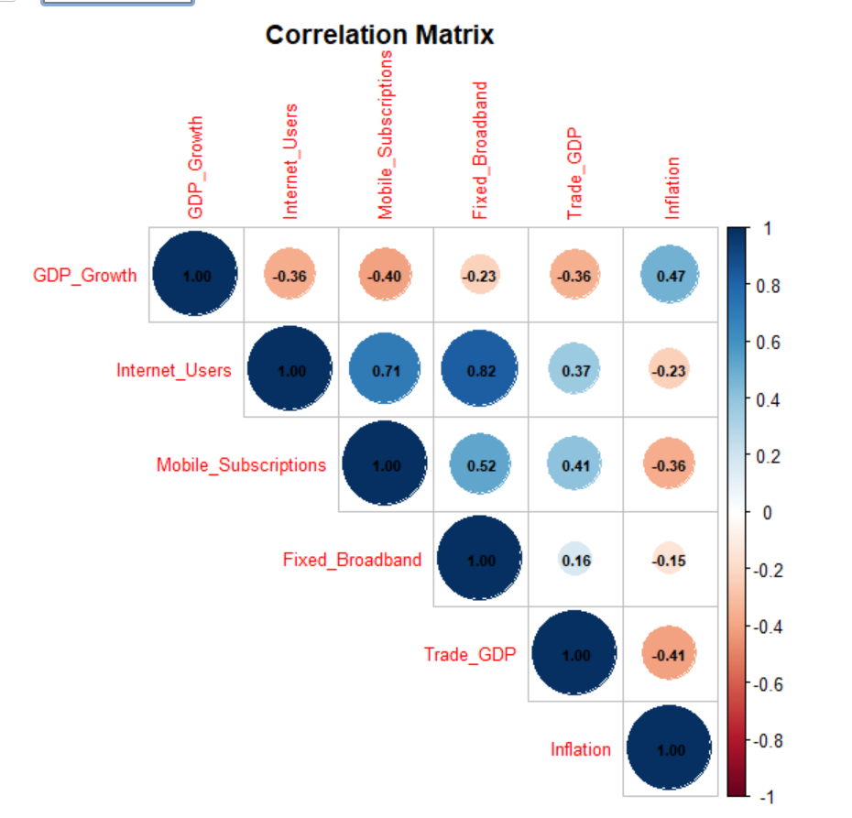
Source: Prepared by the author
Figure 2.3.13 shows several interesting relationships:
- GDP Growth and Internet Users show a weak negative relationship (≈ -0.21) and may represent the time-lag structure in which digitalization and its growth effects act, or may be explained partially by some confounding variable(s).
- GDP Growth and Inflation has a moderate negative relationship (≈ -0.28) per the economic theory that growth and Inflation are inversely related.
- GDP Growth and Trade (% of GDP) have a negative relationship (≈ -0.30) and is largely explained by the high Trade (of Kyrgyzstan) and its volatile negative Growth.
Among the predictors, Internet Users, Mobile Subscriptions, and Fixed Broadband have the highest correlations (0.90–0.96) and may be impacted by Multicollinearity. The Regression may be run with each of the three, and not all three at the same time.
Figure 2.3.14. Results of the pooled OLS regression model
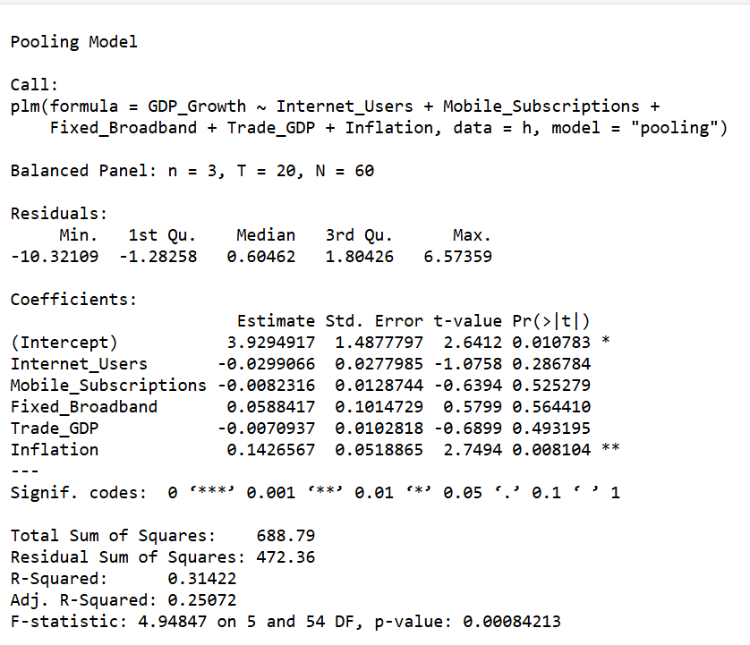
Source: Prepared by the author
The pooled OLS estimation examines the effect of digitalization indicators and selected macroeconomic control variables on GDP growth in Kazakhstan, Uzbekistan, and Kyrgyzstan over the period 2004-2023. The model is based on a balanced panel with 3 countries, 20 years, and 60 observations.
The model was estimated based on the following equation:
GDP_Growth = 3.92 -0.02 ⋅ Internet_Users – 0.01 ⋅ Mobile_Subscriptions + 0.06 ⋅ Fixed_Broadband – 0.01 ⋅Trade_GDP + 0.14 ⋅ Inflation+ɛ
Main results:
The Regression results show that Inflation is the only Explanatory Variable in the pooled model and is statistically significant. Inflation has a coefficient of 0.1427 with a p-value of 0.0081, indicating that with an increase in Inflation, GDP growth increases by approximately 0.143. This positive relationship may be an effect of the specific macroeconomic conditions of the selected countries and may represent the moderate Inflation and High (Economic) Activity of the selected countries. The overall Inflation has a moderate R-squared of 0.3142, meaning that the regressors explain approximately 31.4% of the Variance in GDP growth and the Adjusted (R-squared) of 0.2507 means that the Explanatory model is a moderate model (after accounting for the number of variables).

Figure 2.3.15. Fixed effects model
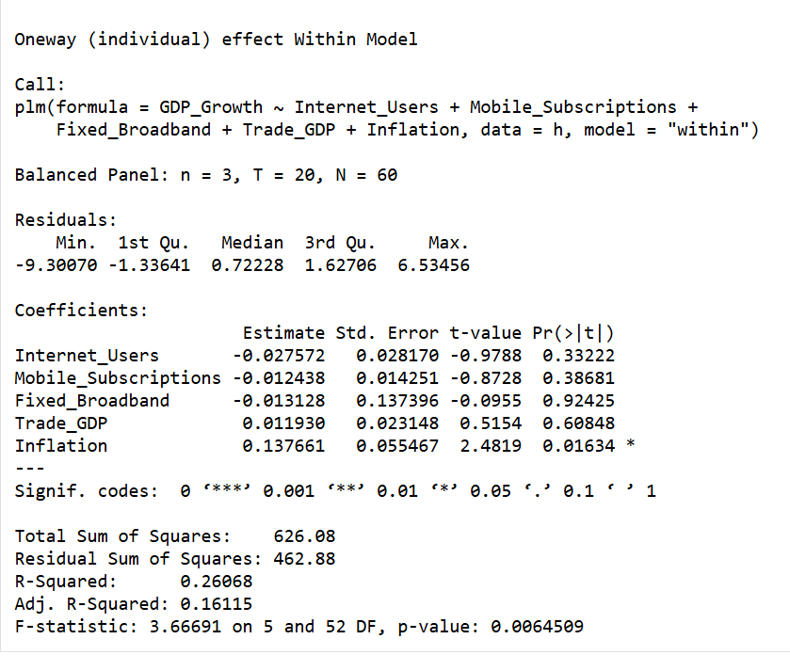
Source: Prepared by the author
This output provides a fixed effects model (within) that allows every country to have its own barrier for unobserved country-specific factors. This model is beneficial in capturing the true effects of the explanatory variables on GDP per capita over the years for every single country. The reported R-squared is 0.2607 and the adjusted R-squared is 0.1612, meaning that, after accounting for unobserved country-specific effects, 26% of the variance in GDP growth is explained by the considered independent variables. This is lower than the explanatory power of the pooled OLS model, however, is reasonable, as the Fixed Effects model is a stricter estimation method that focuses only on the within-country variation. The overall model is still valid, and the rigid F-statistic of 3.6669 and a p-value of 0.00645 attest that the regressors are together significant in explaining GDP growth.
Of the explanatory variables, only inflation has a statistically meaningful estimation in the Fixed Effects model. Its estimation is 0.1377, (p = 0.0163) which means, in the model, an increase of inflation by one unit would cause an increase of GDP growth by 0.138 percent, ceteris paribus. This means, in the countries of the sample, the periods of inflation had the highest GDP growth. This may be due to the general macroeconomic characteristic of developing and transition economy countries of the sample.
The coefficients of the main digitalization variables are estimated with no statistically meaning. Internet users is estimated to have a decrease of 0.0276 (p = 0.3322), which means in the model an increase in Internet Users may be associated with a decrease GDP growth, but this is a statistically meaningless estimation. A similar situation exists for Mobile aggregating subscriptions (β = -0.0124, p = 0.3868). Fixed Broadband has an estimated coefficient of (β = -0.0131, p = 0.9243) and is also meaningless. Trade Openness has a similar but Positive effect to the previous mentioned variables and is also statistically meaningless (β = 0.0119, p = 0.6085). This means no country specific effects, chosen digitalization variables and Trade Openness are meaningfully independent estimators of GDP growth in this model.

Figure 2.3.16. Random effects model
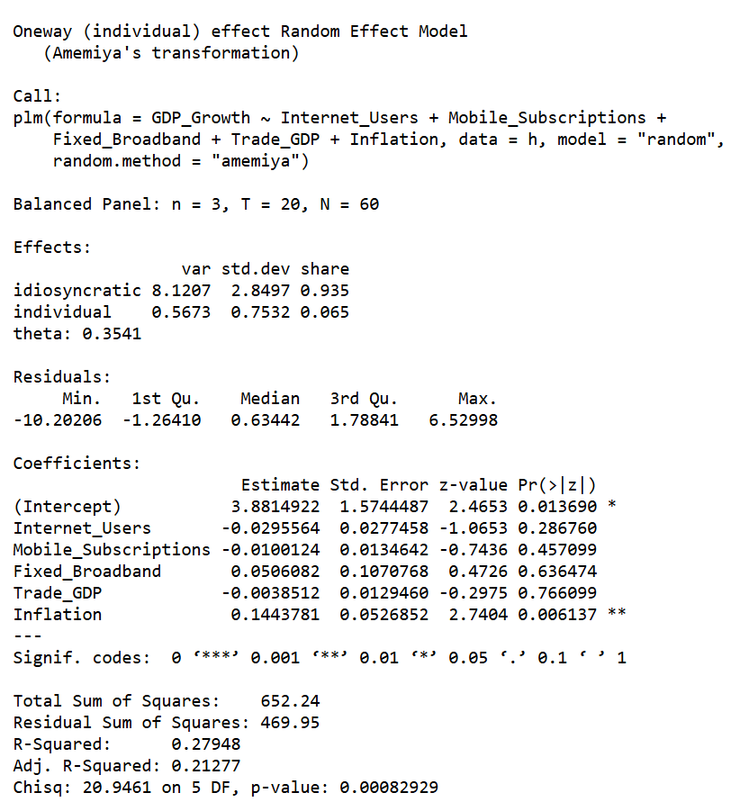
Source: Prepared by the author
The Random Effects model explains the relation of the constructs of digitalization, some macroeconomic control variables, and GDP growth for the countries of Kazakhstan, Uzbekistan, and Kyrgyzstan for the years 2004-2023. The estimation uses a balanced panel of 3 countries, 20 years, and 60 observations. In contrast to Fixed Effects model, the Random Effects model assumes that country-specific effects are random and do not correlate with the independent variables. Because of this, variation both within and between countries can be estimated.
With an adjusted R-squared value of 0.2128, the model shows regressors account for 28% of the variability in GDP growth. While this is a moderate contribution, the model is statistically significant and the joint relevance of the regressors to GDP growth is further substantiated by a Chi-square statistic of 20.9461 and p-value of 0.000829.
Important result:
In the Random Effects model, the only statistically significant regressor is inflation. With a p-value of 0.0061 and a coefficient of 0.1444, inflation is associated with an increase in GDP growth of 0.1444, with other regressors held constant, for every unit increase in inflation. As the only statistically significant regressor in the pooled OLS and Fixed Effects models, inflation was in the same position in all three models. It can be deemed that in the countries of the model, inflation and growth of the economy in correlation with the macroeconomic phenomena of developing countries within the timeframe of the study indicate that periods of high inflation are concomitant with periods of high economic growth.
The remaining explanatory variables do not show statistical significance. Internet users has a negative coefficient (β = -0.0296, p = 0.2868), indicating a weak negative association with GDP growth, but the effect is not statistically reliable. Mobile subscriptions also have a negative and insignificant coefficient (β = -0.0100, p = 0.4571). Fixed broadband has a positive coefficient (β = 0.0506, p = 0.6365), suggesting a possible positive contribution to growth, but the relationship is not statistically significant. Trade openness likewise has a negative and insignificant coefficient (β = -0.0039, p = 0.7661), meaning that no clear independent effect on GDP growth can be identified in this specification.

Figure 2.3.17. F-test
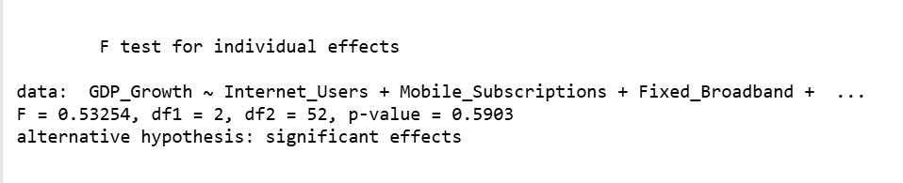
Source: Prepared by the author
The main idea of the F-test was whether it was the Fixed Effects model is more suitable than pooled OLS model.
These are the results of F-test:
F = 0.53254
Degrees of freedom: df1 = 2, df2 = 52
p-value = 0.5903
The tests for country effects came out pretty weak overall. One gave an F of 0.53 and a p value near 0.59 so the idea of fixed differences did not hold up. I think the pooled OLS model ends up looking like the safest choice here. The other models did not really change the picture much anyway.
Figure 2.3.18. Breusch-Pagan test
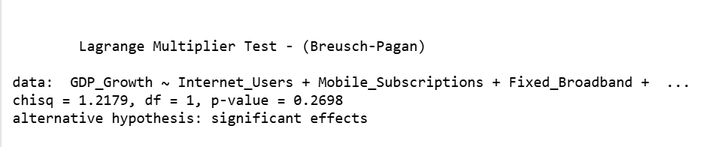
Source: Prepared by the author
The Breusch–Pagan Lagrange Multiplier test was applied to determine whether the Random Effects model is more appropriate than the pooled OLS specification.
Following results:
Chi-square = 1.2179
Degree of freedom = 1
p-value = 0.2698
The chi square version was similar at about 1.22 with p around 0.27 which also pointed away from random effects mattering much. Hausman leaned toward random effects being fine but that alone does not settle it since the earlier checks already suggested neither specification improved on pooling the data.
Figure 2.3.19. Hausman test
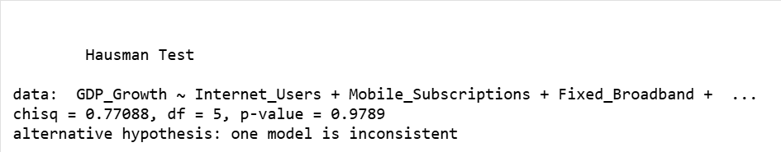
Source: Prepared by the author
The Hausman test is used to compare the Fixed Effects and Random Effects models and to determine which of the two is more appropriate for the panel dataset.
The result shows the following:
- Chi-square = 0.77088
- Degrees of freedom = 5
- p-value = 0.9789
Due to the high p-value of the Hausman test result, the null hypothesis cannot be rejected. Hence, no difference can be concluded, and, therefore, the Random Effects model is regarded as both consistent and efficient compared to the Fixed Effects one.
At the same time, however, it should be noted that the conclusion based on the results of the Hausman test is rather relative. As we remember from previous tests, the F-test result suggested that the Fixed Effects model is statistically insignificant compared to pooled OLS, while the result of the Breusch-Pagan LM test implied that the Random Effects model is not significantly better than pooled OLS either.
Throughout the analysis, I sought to identify the relationship between digitalization and macroeconomic factors in relation to GDP growth in Kazakhstan, Uzbekistan, and Kyrgyzstan. Having estimated different models (including pooled OLS, Fixed Effects, and Random Effects), I noticed that all of them have common features; specifically, only the inflation coefficient turned out to be statistically significant. Thus, for example, in the case of the Random Effects estimation, the corresponding coefficient equaled approximately 0.144, and its p-value was 0.006.
Moreover, having studied this topic, I believed that the main indicators of digitalization-internet users, mobile subscriptions, and fixed broadband-would affect economic growth significantly. However, none of these variables appeared to be statistically significant in my model. This fact does not mean that digitalization is not economically important. It implies that the effects of digitalization are indirect, and other conditions may be needed.
Based on the conducted Hausman test, the Random Effects estimator is preferable to the Fixed Effects one, but when all diagnostic tests are used altogether, the pooled OLS model proves to be the optimal one.
Conclusion for the 2.3 parts
To summarize, econometric analysis was conducted of the effect of indicators of digitalization on GDP growth in Kazakhstan, Uzbekistan, and Kyrgyzstan over 2004-2023 periods with the use of panel data methodology. Results obtained from the Pooled OLS, Fixed Effects, and Random Effects models were relatively consistent among each other. Inflation appears to be the only significant regressor in all the estimated models. At the same time, regressors such as the number of internet users, mobile subscribers, and fixed broadband subscriptions do not demonstrate statistical significance for their impact on GDP growth. Model selection criteria indicate that neither fixed nor random effects are strong enough, and therefore, pooled OLS is recognized as the final choice of the regression.
In general, the obtained empirical results may suggest that in the chosen Central Asian economies, digitalization does not influence economic growth directly in the short run but rather acts as an indicator of development potential and macroeconomic conditions matter more for economic growth. At the same time, based on descriptive statistics and comparative analysis of trends, digitalization can be considered as a long-term factor.

CHAPTER III: ADAPTATION OF INTERNATIONAL EXPERIENCE AND STRATEGIC SUGGESTIONS FOR UZBEKISTAN
3.1 Present situation of digitalization and economic evolution in Uzbekistan
Compared to the two other Central Asian economies considered in this thesis, Uzbekistan represents a special case in its own right, neither representing the standard case of an established benchmark exemplified by Kazakhstan, nor reflecting the structural constraints that define the case of Kyrgyzstan. Rather, Uzbekistan can be viewed as a fast reformer whose digital transition took off in earnest since 2016-2017, but which features certain deficiencies and shortcomings, which, unless remedied, could potentially hinder the emergence of the expected economic gains from digitalization. An accurate assessment of Uzbekistan's strategic strengths, achievements, and potential weaknesses, therefore, appears essential before a policy recommendation could be proposed.
Over the study period (from 2004 to 2023), Uzbekistan displayed remarkable dynamism and resilience, demonstrating an average GDP growth rate of around 3.6% in the panel comprising three Central Asian economies studied here, while being superior to Kyrgyzstan in years marked by shocks and volatility. In the first quarter of 2024, Uzbekistan's economy grew by 6.2% year-on-year, reflecting the continued impact of structural reforms launched since 2017 and sustained government investment in infrastructure and human capital.
Being home to 37 million inhabitants (as per 2024 forecasts), Uzbekistan boasts a population and internal market size greater than those of its neighbors in the region and thus enjoys greater human capital potential, which, if properly tapped via promoting digital skills, might serve as a source of future economic growth. There are several policy areas that form the backbone of Uzbekistan's digital transition strategy. Firstly, one must mention the official Digital Uzbekistan 2030 strategy adopted in 2020 and which sets the goals of integrating digitalization across various domains, including public services and administration, infrastructure, economy, and education. The headline goals set by the strategy include growing the share of the digital economy by at least 2.5 times, achieving ten-fold expansion in software outsourcing revenue to USD 500 million, growing digitalization of government workflows to 90% and joining the top 30 countries globally according to the United Nations e-government development index.
This digital strategy does not exist in isolation. It is embedded within the broader Uzbekistan-2030 National Development Strategy, approved in September 2023, which sets 100 measurable national goals across five key areas-sustainable economic growth, the rule of law, environmental protection, a just state, and a peaceful society-and which explicitly ties human capital, science spending, and innovation performance to the country's aspiration of reaching upper-middle-income status by the end of the decade.
In addition, the government adopted in October 2024 a dedicated Artificial Intelligence Development Strategy until 2030, which allocated USD 50 million for AI infrastructure, set a target of creating a national AI model, and committed to training one million specialists in AI-related fields. The implementation of this AI-driven strategy as part of the overall digital transformation strategy of Uzbekistan means that its government has transcended the first generation of e-government plans, adopting a more advanced approach to achieving deep digital transformation, harnessing advanced technologies and promoting knowledge-based development.
With regards to digital infrastructure, Uzbekistan has made impressive progress, but some quality shortcomings still exist. By 2024, the penetration of the internet had reached 90% of the nation's population, putting Uzbekistan on an even par with its neighbor, Kazakhstan, at 93.39%, and with another neighboring country, Kyrgyzstan, with 92%. In addition, mobile broadband covered 99% of all inhabited areas in Uzbekistan, while 5G networks covered all regional centers by 2024. This was a great accomplishment for the country, but it came with a major caveat. According to World Bank statistics from 2024, the number of safe internet servers in Uzbekistan was 967 per one million people, while in Kazakhstan – 6,914 per one million. Hence, the digital infrastructure was quite shallow compared to that of its benchmark neighbor.
Position of Uzbekistan
The biggest success of Uzbekistan in terms of international digitality was in the area of e-government. In the UN E-Government Development Index (EGDI) 2024, it was placed 63rd taking 0.7999 score, jumping from 69th place in 2022 and put the intermediate target of 0.75 EGDI set for 2025 within the Digital Uzbekistan 2030 Strategy ahead of schedule. This grow helped genuine progress in digital public-service delivery: one clear example is definitely the my.gov.uz portal. Nowadays, it is offering over 560 e-services, the next thing is government's 2023-2024 Digital Government and Digital Region Programs outlined 300 priority digitalization projects, covering public administration digitization, real-economy sector transformation, and regional digital programs. T
The World Bank's GovTech Maturity Index additionally ranked Uzbekistan 43rd out of 198 countries in 2022, taking place it in the highest maturity group (Group A), and rated the country among the world's top four performers on digital skills and innovation in public services. Besides that, Uzbekistan’s innovation ecosystem and IT sector have already developed, starting from a modest base. One example is ICT exports which started from a negligible USD 600,000 in 2017 to USD 140 million in 2022, and then to USD 619.74 million in 2024 - a 40% increase in a single year - affecting the growing international competitiveness of the country's technology service sector. The share of the ICT sector in GDP increased from approximately 2% in 2018 to approximately 5% by 2023, with some estimates placing the digital sector's contribution even higher when broader digital economy activities are included.
Figure 3.1.1. ICT: Service export of Uzbekistan (2013-2024)
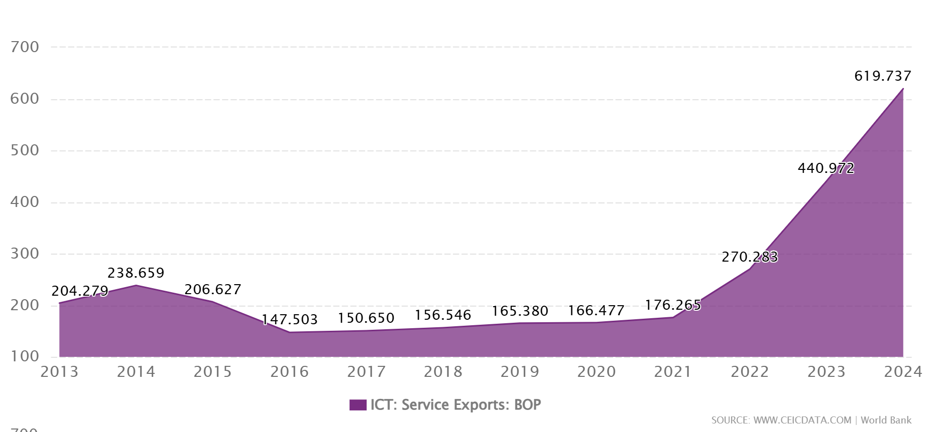
Source: https://www.ceicdata.com/en/uzbekistan/telecommunication/uz-ict-service-exports-bop
The institutional centerpiece of this innovation expansion is IT Park Uzbekistan, established in 2019 under the Ministry of Digital Technologies, which by 2025 supported over 2,800 companies - including more than 730 foreign firms - and offered zero-tax treatment for resident technology companies alongside preferential taxation for their employees. In innovation rankings, Uzbekistan placed 83rd in the WIPO Global Innovation Index (GII) 2024, ahead of Kyrgyzstan (99th) but behind Kazakhstan (78th), and for the third consecutive year maintained its status as a GII innovation overperformer relative to its income level. This situation notwithstanding, Uzbekistan's digital transformation faces three important structural issues which determine its strategic problem and differentiate it from that of Kazakhstan, which already has a more advanced record of digital transformation. The first and probably the key issue is that between having digital infrastructure and using it, which refers especially to companies and businesses.
The report from the OECD review of digital skills for private sector competitiveness in Uzbekistan in 2023, the country has made great strides regarding internet access, quality and cost but "digital uptake among firms remains low" and "the lack of digital skills is a limiting factor affecting the digital transformation of firms."
OECD's report points out three underlying reasons for low firm-level adoption of digital technology: lack of institutional framework to foster SME digitalization, lack of awareness on part of firms regarding advantages associated with digitalization, and low digital skills on part of managers and employees. None of these factors can be dismissed easily. First, despite being an integral part of any country's private sector, SMEs contribute to a major share of employment and economic activity (GDP) in Uzbekistan.
However, the ability of SMEs to harness opportunities created by government's investment in digital infrastructure is hindered by the lack of coordination and lack of measures aimed at fostering SME-friendly and sector-neutral solutions. The current situation in this respect implies that there are various digital tools provided by different agencies and firms have no way of knowing about all of them.
The second challenge related to structural obstacles refers to investments into digitalization and related regulations. Specifically, according to OECD's roadmap on digital investments for Uzbekistan in 2025, data localization requirements, which stipulate that personal data of Uzbek citizens should be kept on the territory of Uzbekistan, may result in certain short-term investments into construction of local data centers; however, the same data localization policy is expected to increase the cost of operating for local firms, make foreign cloud services unviable, and prevent domestic firms from accessing international digital platforms thus hindering innovative benefits generated by them. According to OECD's observations, Uzbekistan was unable to attract more digital foreign direct investments in 2021 compared to pre-COVID level, unlike many other countries.
The third structural obstacle is related to regional and demographic inequalities. As for now, significant differences between urban and rural, and inter-regional levels of digital infrastructure development and opportunities exist in Uzbekistan. Nearly 50% of 37+ million Uzbek citizens live in rural areas where infrastructure is less developed, digital skills are lower, and distance from digital centers of competence is greater. In addition to that, agriculture accounts for 18% of Uzbekistan's GDP and the labor force employed in sectors with relatively low digitization rates. The potential risk is that digitization may result in the concentration of its benefits in Tashkent and other major cities, leaving rural areas and firms behind.
Implications for Uzbekistan are clear in this regard: while significant progress has been achieved regarding development of the infrastructure of e-access and e-governance, Uzbekistan is lacking in the complementary components of the system – broad-scale digital literacy, business adaptation, innovation-fostering regulations, and quality broadband - required for digitalization effects to manifest themselves statistically in growth rates. Therefore, the main strategic challenge for Uzbekistan in addressing the recommendations proposed in Chapter III will be closing this gap and transforming infrastructure into a resource.
3.2. Significance of international experience and strategic advices and their expected economic outcomes to Uzbekistan
From the comparative analysis outlined in Chapter II, it follows that the source of the digital transformation advantage enjoyed by Kazakhstan vis-à-vis Uzbekistan lies not only in its higher degree of digitalization measured by indicators such as internet penetration rate, since now these indicators show almost equal results for all three analyzed states. Instead, the difference has several other components – the depth of digitalization infrastructure, institutional architecture of digital policies operating consistently for over a decade, and the link between digital transformation and goals related to economic diversification. Each of these components implies a separate lesson for Uzbekistan; however, in each case, this lesson must be translated to the specifics of Uzbekistan's structural and institutional framework.
What is transferable from Kazakhstan's experience, and what is not, is therefore the analytical starting point for this section. Kazakhstan's institutional continuity - a digital agenda beginning in 2013, a five-year Digital Kazakhstan program from 2018, the launch of Astana Hub, and DigitEL in 2022 - demonstrates that the primary prerequisite for digital transformation to produce economic results is policy consistency rather than policy ambition.
Uzbekistan has matched Kazakhstan's ambition level but not yet its implementation consistency. What is less directly transferable is Kazakhstan's approach to heavy state-led industrial digitalization in the extractive sector, which relied on a resource-revenue base and investment profile that Uzbekistan does not possess. Uzbekistan's comparative advantage lies in its large young population, lower labor costs, and the potential for ICT services exports and SME-led digital productivity gains - a different economic logic that requires a different digital strategy emphasis.
In response, Uzbekistan should establish a dedicated one-stop-shop for SME digital transformation - analogous to the SME digital support frameworks that OECD countries have developed - that consolidates financial incentives, training programs, certification schemes, and advisory services under a single institutional roof accessible to firms across all sectors and regions.
OECD's review of the status of digital skills development for improving competitiveness in the private sector of Uzbekistan reveals the key aspects of the institutional gap quite explicitly in particular, the fact that there is currently no specialized body responsible for offering SMEs digital tools and guidance on their implementation, that incentives remain limited to IT Park's projects and are focused on IT/BPO-related goals, and that the lack of adequate regulation concerning data protection discourages even skilled firms from implementing innovations and digitalization projects. For this reason, it would be appropriate to establish an SME digitalization one-stop-shop, comparable to those used in the OECD member states, that combines incentives, learning opportunities, certifications, and consulting services all in one place.
The GII 2025 data on Uzbekistan are encouraging in this respect: the country ranked 13th globally in graduates in science and engineering, which indicates a strengthening science and technology supply. For turning science graduates into real digital workers and entrepreneurs, it is crucial for Kazakhstan and Uzbekistan to improve ties between universities, IT Park, and the private sector. In the first case, Astana Hub serves as an illustration of regional public-private tech commercialization; in the second, international offices within IT Park will play this role.
One practical measure includes creating a common monitoring system for digital economy indicators with yearly targets correlated with GII, EGDI, and GovTech indices from the World Bank. In this way, the government can get information on which steps to take next. Kazakhstan already has a practice to estimate government initiatives using international indices, which may be taken up by Uzbekistan to implement digital governance.
Potential effects on Uzbekistan
The most realistic near-term impact of digitalization in the private sector is increased productivity. When small and medium-sized businesses adopt digital technologies (such as specialized accounting and selling systems, CRM, etc.), they decrease administrative costs, increase their market access, and benefit from economies of scale, which small companies usually cannot achieve. According to the OECD's research on both developing and transition economies, there is evidence for this connection.
For Uzbekistan, where SME productivity is currently constrained by limited digital adoption and weak digital skill levels, successful implementation of the SME-focused digital support framework recommended above could produce measurable productivity gains within a five-to-seven-year horizon, which in turn would reduce the cost base of domestic firms and improve their competitiveness in both domestic and export markets.
The second expected outcome is improved public administration efficiency and reduced transaction costs for firms. As the e-government deepening recommendations are implemented - particularly the back-end integration of government data systems and the development of machine-readable regulatory environments - the administrative burden on businesses should decline materially. This improvement would benefit all firms but disproportionately benefit SMEs and new entrants, for whom compliance costs represent a relatively heavier burden. Reduction in administrative transaction costs is one of the clearest and most policy-controllable channels through which digital investment affects growth.
The third expected result can make a problem in trade integration and ICT services exports. Uzbekistan's ICT export trajectory - from USD 0.6 million in 2017 to USD 619.74 million in 2024 - demonstrates that the country already has a comparative advantage in digital services that is growing rapidly. With improved broadband access, alignment of regulations to international standards, and a higher amount of IT specialists, Uzbekistan has enough resources for reaching the annual target of USD 5 billion in ICT exports by 2030. The export revenues will boost the current account, contributing to macroeconomic stability and, thus, creating a favorable environment for investments in other sectors.
A fourth likely outcome will include attracting higher quality FDI. According to the OECD Roadmap for Uzbekistan, digital transformation is one of the important factors for optimizing the investment mix, especially in high-tech sectors. With increasingly standardized laws, data governance, and improved digital infrastructure, Uzbekistan will become more attractive for foreign investors, including companies in the manufacturing industry rather than IT companies working via IT Park only. Kazakhstan serves as a good example of how IT services can lead to industrial diversification in general.
These outcomes are cumulative and interdependent: infrastructure quality enables productive firm use; firm-level digital adoption generates productivity gains; productivity gains improve competitiveness and exports; better competitiveness and governance attract investment; and investment supports deeper innovation. This sequence reflects the logic identified in the OECD and World Bank frameworks, and it explains why the short-run econometric evidence reviewed in Chapter II did not detect significant growth effects from digitalization indicators: Uzbekistan has advanced primarily through the first stages of this sequence-access and e-government - without yet reaching the deeper stages where aggregate growth effects become statistically detectable.

CONCLUSION
This bachelor's project considered the influence of the process of digitalization and modern technologies on economic growth in Central Asia by analyzing the case studies of Kazakhstan, Uzbekistan, and Kyrgyzstan. As a result, it was revealed that digitalization is much more than just technological changes, because it is also essential in regard to modernization, productivity increase, innovation, and competitiveness in the long term.
Firstly, the work described the theoretical background and the research methods for analysis of digitalization and growth, which were based on such important growth models as the Solow model, endogenous growth theory by Romer, and the Schumpeterian theory of growth. Technologies, innovations, spillover effects and digital infrastructure have been identified as determinants for growth within these frameworks, which define digitalization as an impact of the economy through the use of Internet, mobile access, broadband, productivity, innovation, trade integration, institutional changes and other factors.
Secondly, a comparison of the processes of digitalization in Kazakhstan, Uzbekistan, and Kyrgyzstan during 2004-2023 was provided. According to the results, the analyzed countries have demonstrated huge improvements in digitalization over this period. In particular, a massive growth in the share of internet users has been observed. By 2023, the number of internet penetrations reached 92.9% in Kazakhstan, 89% in Uzbekistan, and 88.5% in Kyrgyzstan.
At the same time, there were certain differences in dynamics and development of the process of digitalization, because Kazakhstan showed fast progress at the beginning and has already adopted a proper digitalization strategy, has improved institutional and e-government environment, Uzbekistan has been rapidly developing thanks to recent reforms, and Kyrgyzstan's efforts have been less successful.
Finally, indicators related to economics and digitalization of the selected countries were gathered into a panel data set, which included 3 countries, 20 years, and 60 observations. Dependent variable is GDP growth rate, which is explained by such independent variables as number of internet users, mobile subscribers, fixed broadband subscribers, trade openness, inflation, etc. Description illustrates that the growth rate of GDP has significantly changed over time within the selected region. For instance, its mean value is 3.6%, while Kyrgyzstan experienced a rapid decline in 2020 to -9% due to COVID-19, and Kazakhstan reached its peak level of GDP growth in 2006 at 9.8%.
For the purposes of econometric modeling, pooled OLS, fixed effects, and random effects models were used. According to the results, inflation was found to be the only statistically significant predictor. Specifically, in the pooled OLS regression model, the coefficient for inflation was approximately 0.1427, and the p-value associated with it amounted to 0.0081. Thus, inflation proved to be significantly positively related to GDP growth in the sample. The R-squared for the regression model in question equaled 0.3142. Hence, the selected predictors accounted for 31.4% of variance in GDP growth.
The final chapter of the thesis was dedicated to the application of international experience in Uzbekistan's situation. In this respect, the following progress should be noted: expansion of internet access, development of e-government initiatives, establishment and further development of the IT Park, exports of ICT services, implementation of the Digital Uzbekistan until 2030 strategy. However, one can say that the critical aspect is the transformation of access into effective usage of information and communication technologies in production processes.
Based on the obtained results, some practical recommendations for Uzbekistan can be provided. First, improving the quality of digital infrastructure, which involves fixed broadband infrastructure and ensuring digital security. Second, launching new programs aimed at encouraging the adoption of digital technologies by small and medium enterprises. Third, increasing collaboration among universities, IT Park, startups, and the private sector. Fourth, decreasing regional disparities in the development of ICTs. Fifth, enhancing human capital and digital literacy since it is the key factor of success in exploiting digital technologies.
Overall, the thesis concludes that digitalization is an important long-term factor of economic modernization in Central Asia, but its impact on economic growth is not automatic. The econometric results showed that digitalization indicators did not have a statistically significant direct short-term effect on GDP growth in the selected model. Nevertheless, taking into account the theoretical and comparative analysis, one could conclude that digitalization will play an essential role in sustainable development. At the same time, the actual influence of such a phenomenon on a country's economy would depend on certain aspects, including the quality of infrastructure, digital literacy, business readiness, innovativeness, and institutional effectiveness.

REFERENCES:
Ⅰ. Decisions and decrees of the President of the Republic of Uzbekistan:
  - President of the Republic of Uzbekistan. (2020, October 5). Decree No. PF-6079 on the approval of the "Digital Uzbekistan - 2030" strategy and measures for its effective implementation - https://lex.uz/docs/5030957;
  - President of the Republic of Uzbekistan. (2023, September 11). Decree No. PF-158 on the Strategy "Uzbekistan - 2030" - https://lex.uz/docs/-6600413;
  - President of the Republic of Uzbekistan. (2024, October 14). Resolution No. PQ-358 on Approval of the Strategy for the Development of Artificial Intelligence Technologies until 2030 - https://lex.uz/docs/7158604
Ⅱ. Data published by republican and international organizations:
  - World Bank. World Development Indicators (WDI) - https://databank.worldbank.org/source/world-development-indicators;
  - International Telecommunication Union (ITU). Statistics - https://www.itu.int/en/ITU-D/Statistics/pages/stat/default.aspx;
  - OECD. (2019). Measuring the Digital Transformation: A Roadmap for the Future. Paris: OECD Publishing - https://www.oecd.org/en/publications/measuring-the-digital-transformation_9789264311992-en/full-report/component-8.html;
  - United Nations. E-Government Development Index Data Center - https://publicadministration.un.org/egovkb/en-us/data-center;
  - WIPO. (2024). Global Innovation Index 2024 results - https://www.wipo.int/web-publications/global-innovation-index-2024/en/index.html
Ⅲ. Special reports and regional studies:
  - Bianchini, M., & Kwon, I. (2023). Private Sector Digitalisation in Central Asia. OECD Central Asia Initiative / European Union - https://www.oecd.org/en/about/programmes/oecd-eurasia-competitiveness-programme.html;
  - World Bank. (2023). Uzbekistan Digital Inclusion Project. Washington, DC: World Bank - https://documents.worldbank.org/en/publication/documents-reports/documentdetail/099060723031518423;
  - World Bank. (2024, February 22). World Bank to Help Expand Digital Infrastructure for Underserved Areas in Kazakhstan - https://www.worldbank.org/en/news/press-release/2024/02/22/world-bank-to-help-expand-digital-infrastructure-for-underserved-areas-in-kazakhstan;
  - GSMA. (2025). Uzbekistan’s Digital Policy Advancements Set the Scene for M360 Eurasia - https://www.gsma.com/solutions-and-impact/connectivity-for-good/public-policy/uzbekistans-digital-policy-advancements-set-the-scene-for-m360-eurasia/;
  - Startup Genome. (2025). Uzbekistan: Central Asia’s Fastest-Rising Startup Ecosystem - https://startupgenome.com/;
  - CEIC Data. Uzbekistan ICT Service Exports: BoP - https://www.ceicdata.com/en/uzbekistan/telecommunication/uz-ict-service-exports-bop
Ⅳ. Scientific-theoretical and academic sources:
  - Solow, R. M. (1956). A Contribution to the Theory of Economic Growth. Quarterly Journal of Economics - The Quarterly Journal of Economics, Volume 70, Issue 1, February 1956, Pages 65–94;
  - Solow, R. M. (1957). Technical Change and the Aggregate Production Function. Review of Economics and Statistics, 39(3), 312-320 - https://www.jstor.org/stable/1926047?utm;
  - Romer, P. M. (1990). Endogenous Technological Change. Journal of Political Economy, 98(5), S71–S102 - https://www.journals.uchicago.edu/doi/10.1086/261725;
  - Aghion, P., & Howitt, P. (1992). A Model of Growth Through Creative Destruction.Econometrica, 60(2), 323-351 - https://www.jstor.org/stable/2951599;
  - Shapiro, C., & Varian, H. R. (1999). Information Rules: A Strategic Guide to the Network Economy. Harvard Business School Press;
  - Brynjolfsson, E., & McAfee, A. (2014). The Second Machine Age: Work, Progress, and Prosperity in a Time of Brilliant Technologies. W.W. Norton - https://wwnorton.com/books/the-second-machine-age/;
  - Barro, R. J. (1991). Economic Growth in a Cross Section of Countries. Quarterly Journal of Economics, 106(2), 407–443 - https://academic.oup.com/qje/articleabstract/106/2/407/1905452?login=false
  - Hausman, J. A. (1978). Specification Tests in Econometrics. Econometrica, 46(6), 1251–1271 - https://www.jstor.org/stable/1913827
Ⅴ. Internet pages and official portals:
  - IT Park Uzbekistan. About IT Park - https://www.it-park.uz/en/itpark;
  - Astana Hub - https://astanahub.com/ru/;
  - Ministry of Digital Technologies of the Republic of Uzbekistan - https://gov.uz/en/digital;
  - Government Portal of the Republic of Uzbekistan - https://gov.uz/en

World Bank. (2016). World Development Report: Digital Dividends. Washington, DC.
OECD publishing, OECD definitions of the ICT sector, the content and media sector, and information industries based on ISIC Rev.5, June 2025
Solow, R. (1957). Technical change and the aggregate production function. Review of Economics and Statistics, 39(3), 312-320.
Jorgenson, D., & Stiroh, K. (2000). Raising the speed limit: U.S. economic growth in the information age. Brookings Papers on Economic Activity, 1–43.
Brynjolfsson, E., & McAfee, A. (2014). The Second Machine Age. W.W. Norton.
Shapiro, C., & Varian, H. (1999). Information Rules. Harvard Business School Press.
Brynjolfsson, E., & McAfee, A. (2014). The Second Machine Age.
OECD. (2020). Digital Economy Outlook.
OECD. (2011). ISIC Rev.3 Technology Intensity Definition.
Romer, P. (1990). Endogenous technological change. Journal of Political Economy, 98(5), S71–S102.
Solow, R. (1956). A contribution to the theory of economic growth. Quarterly Journal of Economics.
Solow, R. (1957). Technical change and the aggregate production function. Review of Economics and Statistics.
Romer, P. (1990). Endogenous technological change. Journal of Political Economy.
Aghion, P., & Howitt, P. (1992). A model of growth through creative destruction. Econometrica.
OECD (2023). Digital Economy Outlook.
Bresnahan, T., & Trajtenberg, M. (1995). General purpose technologies. Journal of Econometrics.
OECD (2023). Digital Economy Outlook.
IMF (2018). Measuring the Digital Economy.
World Bank (2016). World Development Report: Digital Dividends
Brynjolfsson, E., & McAfee, A. (2014). The Second Machine Age.
IMF (2018). Measuring the Digital Economy.
Czernich, N., et al. (2011). Broadband infrastructure and economic growth. Economic Journal.
Qiang, C., Rossotto, C., & Kimura, K. (2009). Economic impacts of broadband. World Bank Policy Research Working Paper.
Barro, R. (1991). Economic growth in a cross-section of countries. Quarterly Journal of Economics.
Baltagi, B. (2008). Econometric Analysis of Panel Data.
Islam, N. (1995). Growth empirics: A panel data approach. Quarterly Journal of Economics.
Solow (1957). Technical change and aggregate production function.
OECD (2023). Digital Economy Outlook.
Barro & Sala-i-Martin (2004). Economic Growth.
Mankiw, Romer & Weil (1992). A contribution to the empirics of economic growth.
Wooldridge, J. (2010). Econometric Analysis of Cross Section and Panel Data.
Baltagi (2008).
Hausman, J. (1978). Specification tests in econometrics.
Greene, W. (2012). Econometric Analysis.
IMF (2018). Measuring the Digital Economy.
Czernich et al. (2011). Broadband infrastructure and economic growth
Qiang et al. (2009). Economic impacts of broadband.
OECD. Improving Framework Conditions for the Digital Transformation of Businesses in Kazakhstan (2023). Used for: why Kazakhstan is the benchmark, the 2013 start of the digital agenda, the Digital Kazakhstan strategy, DigitEL, the 11% firm-use figure, infrastructure quality problems, diversification logic, and COVID-related business digitalization.
World Bank country data pages for Kazakhstan, Uzbekistan, and the Kyrgyz Republic (2024 data). Used for: GDP, GDP per capita, internet users, and GDP growth comparisons.
Marco Bianchini and Insung Kwon. Private Sector Digitalization in Central Asia (OECD / EU Central Asia Initiative, 2023).
Jussupova, G., Bokayev, B., & Zhussip, D. Digital Government Maturity as a Technologically New E-Government Maturity Model: Experience of Kazakhstan (2019).
Bokayev, B. et al. Transforming E-government in Kazakhstan: A Citizen-Centric Approach (2021).
OECD. Improving Framework Conditions for the Digital Transformation of Businesses in Kazakhstan (2023).
World Bank. Press release on the Digital Acceleration for an Inclusive Economy (DARE) Project, February 22, 2024.
United Nations. UN E-Government Development Index 2024 country profiles / data center for Kazakhstan, Uzbekistan, and Kyrgyzstan.
WIPO. Global Innovation Index 2024 executive summary.
WIPO. Kazakhstan country profile, Global Innovation Index 2024.
World Bank indicator pages for secure internet servers and internet use.
OECD. Improving Framework Conditions for the Digital Transformation of Businesses in Kazakhstan (2023).
WIPO. Kazakhstan country profile, Global Innovation Index 2024.
Bokayev, B. et al. Transforming E-government in Kazakhstan: A Citizen-Centric Approach (2021).
Shodiev, T., Turayey, B., & Shodiyev, K. ICT and Economic Growth Nexus: Case of Central Asian Countries (2021).
Kuldasheva, Z., Eshov, M., & Ismailova, N. International Trade and Economic Growth in Central Asia: The Role of Digital Economy (2023).
World Bank. Press release on the Digital Acceleration for an Inclusive Economy (DARE) Project, February 22, 2024.
World Bank. Uzbekistan Digital Inclusion Project (2023).
OECD. Digital Skills for Private Sector Competitiveness in Uzbekistan (2023).
United Nations. UN E-Government Development Index 2024 country profiles / data center for Kazakhstan, Uzbekistan, and Kyrgyzstan.
OECD. (2019). Measuring the Digital Transformation: A Roadmap for the Future. Paris: OECD Publishing.
OECD. (2022). The OECD Going Digital Measurement Roadmap. OECD Digital Economy Papers.
Magoutas, A. I., Chaideftou, M., Skandali, D., & Chountalas, P. T. (2024). “Digital Progression and Economic Growth: Analyzing the Impact of ICT Advancements on the GDP of European Union Countries.” Economies, 12(3), 63.
Correa, E., & Esquivias, M. A. (2025). “The Impact of Digitalization, Education, and Institutional Quality on Economic Growth: A Comparative Analysis between Sub-Saharan Africa and Middle East Countries.” Scientific African, Article 101423.
Shodiev, T., Turayey, B., & Shodiyev, K. (2021). “ICT and Economic Growth Nexus: Case of Central Asian Countries.” Procedia of Social Sciences and Humanities, 1.
Kuldasheva, Z., Eshov, M., & Ismailova, N. (2023). “International Trade and Economic Growth in Central Asia: The Role of Digital Economy.” In Proceedings of the International Conference on Future Networks and Distributed Systems (ICFNDS ’23).
Kurmanov, N., et al. (2025). “ICTs’ Impact on Energy Consumption and Economic Growth in the Countries of Central Asia: An Empirical Analysis.” International Journal of Energy Economics and Policy.
Bianchini, M., & Kwon, I. (2023). Private Sector Digitalisation in Central Asia. OECD Central Asia Initiative / European Union.
Bianchini, M., & Kwon, I. (2023). Private Sector Digitalization in Central Asia. OECD Central Asia Initiative / European Union.
WIPO. (2024). Global Innovation Index 2024; World Bank. World Development Indicators / DataBank for internet use, mobile subscriptions, broadband, secure internet servers, and high-technology exports.
OECD. (2023). Improving Framework Conditions for the Digital Transformation of Businesses in Kazakhstan. Paris: OECD Publishing.
Ministry of Digital Technologies of the Republic of Uzbekistan / China Academy of Information and Communications Technology (CAICT). Uzbekistan Digital Economy Overview and Vision 2030. Tashkent / Beijing, November 2024. Available at: https://aict.uz/caict_uzbekistan_digital_economy_overview_vision_2030.pdf
Government of Uzbekistan / Embassy of Uzbekistan. Uzbekistan-2030 Strategy -100 Goals for National Development. Approved September 2023. Available at: https://www.uzbekembassy.in/uzbekistan-launches-the-updated-and-ambitious-uzbekistan-2030-strategy-for-national-development/
Government of the Republic of Uzbekistan / Presidential Decree No. RP-358. Strategy for the Development of Artificial Intelligence Technologies until 2030. Tashkent, October 14, 2024. Available at: https://lex.uz/en/docs/7159258
United Nations. UN E-Government Development Index 2024: Country Data. New York: United Nations, 2024. Available at: https://publicadministration.un.org/egovkb/en-us/Data-Center
Government of the Republic of Uzbekistan. Digital Government and Digital Region Programs for 2023-2024 (300 priority projects). Tashkent, 2023. Available at: https://gov.uz/en/activity_page/digital_technology
Permanent Mission of Uzbekistan. Digital Transformation of Uzbekistan Promotes Regional Integration in Central Asia. 2024. Available at: https://www.uzbekistan.org.ua/en/news/7390-digital-transformation-of-uzbekistan-promotes-regional-integration-in-central-asia
TAdviser / CEIC Data. Export of ICT Services from Uzbekistan Grew by 40% over the Year and Reached $620 Million. December 2025. Available at: https://tadviser.com/index.php/Article:ICT_market_of_Uzbekistan
Abdurashidova, M.S., and Balbaa, M.E. The Role of Investment in Accelerating Digital Transformation within the Economy of Uzbekistan. Proceedings of the 8th International Conference on Future Networks & Distributed Systems (ICFNDS 2024). ACM Digital Library, 2024. Available at: https://dl.acm.org/doi/10.1145/3726122.3726274
Startup Genome / StartupBlink. Uzbekistan: Central Asia's Fastest-Rising Startup Ecosystem. Global Startup Ecosystem Report 2025. Available at: https://startupgenome.com/report/gser2025/uzbekistan-central-asias-fastest-rising-startup-ecosystem
WIPO. Global Innovation Index 2024. Geneva: World Intellectual Property Organization, 2024. Available at: https://www.wipo.int/web-publications/global-innovation-index-2024
OECD. Improving Framework Conditions for the Digital Transformation of Businesses in Kazakhstan. Paris: OECD Publishing, 2023.
OECD. SME Digitalization to Manage Shocks and Transitions. OECD D4SME Survey 2024. Paris: OECD Publishing, September 2024.
WIPO, Global Innovation Index
OECD. Insights on the Business Climate in Uzbekistan. Paris: OECD Publishing, 2023 - https://www.oecd.org/content/dam/oecd/en/publications/reports/2023/05/insights-on-the-business-climate-in-uzbekistan_9ac46b98/317ce52e-en.pdf

